**TABLE OF CONTENTS**

Title of the project………………………………………………………….1

Introduction & Objective of the Project………..................2-3

Tools /Environment Used………………………………………..4

Requirement and Analysis………………………………………………..5-12

* 1. Feasibility Study……………………………………………………..7-8
  2. Problem Definition………………………………………………..8
  3. Project scheduling…………………………………………………..9
  4. Data Flow Diagram…………………………………………………10-11

Complete Structure………………………..................................11-17

1. Modules and their description……………………………………11
2. Data structure…………………………………………………………….12-15
3. Process logic of the modules………………………………………16
4. List of reports generated ……………………………………………17

Project Code………………………………………………………………18-141

Testing…………………………………………………………………18-141

Project Screenshot…………………………………………………144-148

Implementation of Security…………………………………..142-143

Future scope and enhancement…………………………………155

Conclusion ………………………………………………..................156

1. **TITLE OF THE PROJECT**

**ONLINE SUPPLY CHAIN MANAGEMENT**

**SYSTEM**

2. INTRODUCTION OF THE PROJECT

* The **SCM system** is a management of a network of interconnected [businesses](http://en.wikipedia.org/wiki/Business) involved in the provision of [product](http://en.wikipedia.org/wiki/Product_(business)) and [service](http://en.wikipedia.org/wiki/Service_(economics)) packages required by the end customers in a [supply chain](http://en.wikipedia.org/wiki/Supply_chain).
* Supply chain management spans all movement and storage of [raw materials](http://en.wikipedia.org/wiki/Raw_material), work-in-process inventory, and finished goods from point of origin to point of consumption.
* A simple supply chain is made up of several elements that are linked by the movement of products along it. The supply chain starts and ends with the customer.
* **Customer:** The customer starts the chain of events when they decide to purchase a product that has been offered for sale by a company. The customer contacts the sales department of the company, which enters the sales order for a specific quantity to be delivered on a specific date. If the product has to be manufactured, the sales order will include a requirement that needs to be fulfilled by the production facility.
* **Planning:** The requirement triggered by the customer’s sales order will be combined with other orders. The planning department will create a production plan to produce the products to fulfill the customer’s orders.
* **Purchasing:** The purchasing department receives a list of raw materials and services required by the production department to complete the customer’s orders. The purchasing department sends purchase orders to selected suppliers to deliver the necessary raw materials to the manufacturing site on the required date.
* **Inventory:** The raw materials are received from the suppliers, checked for quality and accuracy and moved into the warehouse. The supplier will then send an invoice to the company for the items they delivered. The raw materials are stored until they are required by the production department.
* **Production:** Based on a production plan, the finished products ordered by the customer are manufactured using the raw materials purchased from suppliers. After the items have been completed and tested, they are stored back in the warehouse prior to delivery to the customer.
* **Transportation:** When the finished product arrives in the warehouse, the shipping department determines the most efficient method to ship the products so that they are delivered on or before the date specified by the customer. When the goods are received by the customer, the company will send an invoice for the delivered products.

2.1. OBJECTIVES OF THE PROJECT

1. To study the tools and techniques of Supply chain management.
2. To study the inventory control measures in Supply chain management.
3. To study the demand forecast of Supply chain management.
4. Sell company’s product at lower rate.
5. To determine the stock level in this management.
6. To identify problems related to supply chain management and to find out suitable measures to overcome them.
7. To study the inventory management procedure.
8. To make a comparative study of Supply chain management in last few years using ratio analysis technique.

These projects have some more features:

• System Connectivity

• No data duplication

• No Paper Work Required

• Time Efficient

• Cost Efficient

• Automatic data validation

• User friendly environment

• Data security and reliability

• Fast data insertion & retrieval

• Easy performance check

3. TOOLS/ENVIRONMENT USED

**3.1 Hardware Requirement for Server Side :**

|  |  |
| --- | --- |
| **COMPONENT** | **MINIMUM SPECIFICATION** |
|  |  |
| 1. Processor | Pentium IV |
| 1. Memory | 512 MB |
| 1. HDD | 1. B |

**3.2 Software Requirement :**

|  |  |
| --- | --- |
| **Use of Software** | **Name of Software** |
|  |  |
| 1. Operating System | Window 7, XP-SP3 |
| 1. Front End | PHP, HTML |
| 1. Back End | MySql 5.5 |
| 1. For Documentation | MS-Office 2007 |

**4-REQUIREMENTS AND ANALYSIS**

**4.1FEASIBILITY STUDY :**  
All projects are feasible given unlimited resources and infinite time. Unfortunately the development of computer-based system in many cases is more likely to be plagued by scarcity of resources and delivery date. Hence, we have made use the concept of reusability that is what Object Oriented Programming (OOPS) is all about.  
The feasibility report of the project holds the advantages and flexibility of the project. This is divided into three sections:

1. Economical Feasibility
2. Technical Feasibility
3. Behavioral Feasibility  
    **1. Economic Feasibility :**  
   Economic analysis is the most frequently used method for evaluating the effectiveness of the candidate system. More commonly known as cost/benefit analysis, the procedure is to be determining the benefits and savings that are expected from a candidate and compare them with costs. If benefits outweigh costs, then the decision is made to design and implement the system.

A systems financial benefit must exceed the cost of developing that system. i.e. a new system being developed should be a good investment for the organization. Economic feasibility considers the following:  
**i.** The cost to conduct a full system investigation.   
**ii.** The cost of hardware and software for the class of application.   
**iii**. The benefits in the form of reduced cost or fewer costly errors.   
**iv**. The cost if nothing changes (i.e. the proposed system is not developed).

The proposed **Online SCM System** is economically feasible because  
**i.** The system requires very less time factors. 

**ii**. The system will provide fast and efficient automated environment instead of slow and error

prone manual system, thus reducing both time and man power spent in running the system.  
**iii**. The system will have GUI interface and very less user-training is required to learn it.

**iv**. The system will provide service to view various information for proper managerial decision making. 

**2. Technical Feasibility:**  
Technical feasibility centers around the existing computer system (Hardware and Software etc) and to what extend it support the proposed addition.

In this project, all the necessary cautions have been taken care to make it technically feasible. Using a key the display of text/object is very fast. Also, the tools, operating system and programming language used in this localization process is compatible with the existing one.  
 **3. Behavioral Feasibility:**  
People are inherently resistant to change, and computers have been known to facilitate change. An estimate should be made of how strong a reaction the user staff is likely to have toward the development of a computerized system. Therefore it is understandable that the introduction of a candidate system requires special efforts to educate and train the staff. The software that is being developed is user friendly and easy to learn. In this way, the developed software is truly efficient and can work on any circumstances , tradition ,locales. Behavioral study strives on ensuring that the equilibrium of the organization and status quo in the organization are nor disturbed and changes are readily accepted by the users.

**4.2PROBLEM DEFINITION**

**DISADVANTAGES OF OLD SYSTEM**  
  
As we know the manual processing is quite tedious, time consuming, less accurate in comparison to computerized processing. Obviously the present system is not is exception consultant encountering all the above problems.  
**1.** Time consuming.  
**2.** It is very tedious.  
**3.** All information is not placed separately.  
**4.** Lot of paper work.  
**5.** Slow data processing.  
**6.** Not user-friendly environment.  
**7.** It is difficult to found records due file

**ADVANTAGES OF NEW SYSTEM**  
  
In new computerized system I tried to give these facilities.  
**1.** Manually system changes into computerized system.  
**2.** Friendly user interface.  
**3.** Time saving.  
**4.** Save paper work.  
**5.** Connecting to database so we use different type of queries, data report.  
**6.** Give facility of different type of inquiry.  
**7.** Formatted data.

* 1. **PROJECT SCHEDULING**

**GANTT CHART**

|  |  |  |  |  |  |  |  |  |
| --- | --- | --- | --- | --- | --- | --- | --- | --- |
| **Task No**. | **Task** | **oct- Nov** | **Nov-Dec** | **Jan** | **Jan- Feb** | **Feb** | **Mar** | **Apr** |
| 1 | Requirement Analysis |  |  |  |  |  |  |  |
| 2 | Design |  |  |  |  |  |  |  |
| 3 | Coding |  |  |  |  |  |  |  |
| 4 | Testing |  |  |  |  |  |  |  |
| 5 | Documentation |  |  |  |  |  |  |  |
| 6 | Implementation |  |  |  |  |  |  |  |
| 7 | Final Review |  |  |  |  |  |  |  |

**PERT CHART**

A PERT chart is a project management tools used to schedule, organize, and coordinate tasks within a project. PERT stands for **Program Evaluation Review Technique.** A PERT chart presents a graphic illustration of a project as network diagram consisting of numbered nodes(either circles or rectangles) representing events, or milestones in the project linked by labeled vectors (directional lines) representing tasks in the project.

The direction of the arrows on the lines indicates the sequence of tasks.

**Programming**

**Beta Testing**

**SRS And Design**

**Alpha Testing**

10

8

5

3

10 15 30 10 10

1

2

11

9

7

6

4

3 10 10 10 5

**Writing Manuals**

**Buy Hardware**

**User Requirement And Analysis**

**User Test**

**Training**

**Installation**

**SOFTWARE ENGINEERING CONCEPT**

**Waterfall Model**

This is the most common and classic of life cycle models, also referred to as a linear sequential life cycle model. It is very simple to understand and use. In a waterfall model, each phase must be completed in its entirety before the next phase can begin. At the end of each phase, a review takes place to determine if the project is on the right path and whether or not to continue or discard the project. Unlike what I mentioned in general model, phase does not overlap in a waterfall model.

**Waterfall Model Life cycle**

**Requirements**

**Design**

**Implementation and Unit Testing**

**Integration and System Testing**

**Operation**

**4.4 Data Flow Diagram**

0 LEVEL DFD : CONTEXT DIAGRAM

DISTRIBUTOR

DISTRIBUTOR

Dist_detail, product_detail, reorder_info, feedback_info, delivery_info invoice_detail, reorder_detail, stock_detail dist_info, order_info, retailer_info, order_info payment_info, stock_info, invoice_info, s_agent_info product_info

SALES_AGENT

SALES_AGENT

S_agent_detail, s_agent_info, order_info,

Delivery_detail , payment_info, delivery_info, payment_detail invoice_info

retailer_detail, retailer_info, invoice_info, order_info,

order_detail, payment_detail payment_info

RETAILER

RETAILER

1 LEVEL DFD

**Retailer**

Order detail

Stock info

**Stock**

**Database**

**Customer**

**Distributor**

2 LEVEL DFD

Sales_agent_DB

Sales_agent_info

Sales_agent_detail

**SALES_AGENT**

**SALES_AGENT**

Sales_agent_info

Delivery_detail, payment_detail

Invoice_info, delivery_info, payment_info, sales_agent_info, order_info

Reorder_info Product_DB

Stock_info, product_info,

Reorder_info, feedback_info, retailer_info, order_info, delivery_info, payment_info, stock_info, invoice_info, s_agent_info, distributor_info, product_info

Product_info

Stock_detail,

reorder_detail, product detail

Dist_info, invoice_info

Dist_detail, invoice_detail, product_detail

**DISTRIBUTOR**

**DISTRIBUTOR**

Invoice_info, retailer_info, order_info, delivery_info

Retailer_detail, order_detail, feedback

**RETAILER**

**RETAILER**

**4.5 ER Diagram**

Is supplied by

Stored in

Is of

Supplies to

places

Order

has

Is in

Retailer

Invoice

Category

product

distributor

Sales agent

stock

**5. COMPLETE STRUCTURE**

**5.1 MODULES & THEIR DESCRIPTION**

* **ADMIN OR DISTRIBUTOR**

The DISTRIBUTOR module is the most important module of the system since it configures the complete processing by checking the validity of the retailer and its main job is to fetch the information from the database and provide them to the sales agent and the retailer. It also evaluates the orders and no. of products and receives the feedback from the retailer.

* **SALES AGENT**

The sales agent module is the next module of the system as it supplies the product to each retailer. An [entity](http://www.investorguide.com/definition/entity.html) that takes noncompeting [products](http://www.businessdictionary.com/definition/product.html) or product lines from the distributor and sells them to [retailers](http://www.businessdictionary.com/definition/retailer.html) are called as sales agent. It takes the information from the retailer and gives it to the distributor. It acts as a mediator for the retailer. It works on the demand of the products raised by the retailer.

* **RETAILER**

The retailer is the next module of the system. It gives the details to the distributor for being registered. It places order to the sales agent for the product in demand. The retailer gives the payment to the sales agent and receives back the receipt.

* **PAYMENT**

The payment module consists of all the transactions made by the retailer, sales agent and distributor in buying the products.

* **STOCK**

This module is maintained by the distributor as it consists of the product details i.e. model no. , color, product id, etc. which are the details of the product as well as carries the information of stock level and reorder level.

**5.2 Data Structure**

**5.2.1-Registration**

|  |  |  |
| --- | --- | --- |
| **Field Name** | **Data Type** | **Length** |
| UId | VARCHAR | 15 |
| Name | VARCHAR | 20 |
| Email-id | VARCHAR | 20 |
| Contact | INT | 11 |
| Address | VARCHAR | 100 |
| Gender | VARCHAR | 10 |
| Pin Code | INT | 6 |
| Password | VARCHAR | 20 |
| UserType | CHAR | 20 |

**7.2.2-Login**

|  |  |  |
| --- | --- | --- |
| **Field name** | **Data type** | **Length** |
| Email-id | VARCHAR | 20 |
| Name | VARCHAR | 20 |
| Password | VARCHAR | 20 |
| Usertype | VARCHAR | 10 |

**7.2.3 Distributor**

|  |  |  |
| --- | --- | --- |
| **Field Name** | **Data Type** | **Length** |
| UId | VARCHAR | 15 |
| Name | VARCHAR | 20 |
| Email-id | VARCHAR | 20 |
| Contact | INT | 11 |
| Address | VARCHAR | 100 |
| Gender | VARCHAR | 10 |
| Pin Code | INT | 6 |
| Password | VARCHAR | 20 |

**7.2.4 Sales_Agent**

|  |  |  |
| --- | --- | --- |
| **Field Name** | **Data Type** | **Length** |
| UId | VARCHAR | 15 |
| Name | VARCHAR | 20 |
| Email-id | VARCHAR | 20 |
| Contact | INT | 11 |
| Address | VARCHAR | 100 |
| Gender | VARCHAR | 10 |
| Pin Code | INT | 6 |
| Password | VARCHAR | 20 |

**7.2.5 Retailer**

|  |  |  |
| --- | --- | --- |
| **Field Name** | **Data Type** | **Length** |
| UId | VARCHAR | 15 |
| Name | VARCHAR | 20 |
| Email-id | VARCHAR | 20 |
| Contact | INT | 11 |
| Address | VARCHAR | 100 |
| Gender | VARCHAR | 10 |
| Pin Code | INT | 6 |
| Password | VARCHAR | 20 |

**7.2.6-Product_Details**

|  |  |  |
| --- | --- | --- |
| **Field Name** | **Data Type** | **Length** |
| Product_id | VARCHAR | 50 |
| Product _name | VARCHAR | 50 |
| Product_category | VARCHAR | 50 |
| Product_price | INT | 10 |
| Product_color | CHAR | 10 |

**7.2.7-Payment_detail**

|  |  |  |
| --- | --- | --- |
| **Field Name** | **Data Type** | **Length** |
| Payment_id | VARCHAR | 20 |
| Payment_day | VARCHAR | 10 |
| Payment_date | DATE | 10 |
| Payment_price | INT | 10 |
| Payment_type | VARCHAR | 50 |

**7.2.8 Stock Table**

|  |  |  |
| --- | --- | --- |
| **Column Name** | **Data Type** | **Key constraint** |
| Stock_id | VARCHAR | 20 |
| Product_id | VARCHAR | 20 |
| Product_available | INT(10) | 20 |
| Product_required | INT(10) | 20 |
| Reorder_level | INT | 20 |

**7.2.9 Order Table**

|  |  |  |
| --- | --- | --- |
| **Column Name** | **Data Type** | **Key constraint** |
| Order_no | VARCHAR | 20 |
| Order_date | DATE | 15 |
| Product_id | VARCHAR | 20 |
| Salesagent_id | VARCHAR | 20 |
| Location | CHAR | 30 |

**7.2.10 Feedback Table**

|  |  |  |
| --- | --- | --- |
| **Column Name** | **Data Type** | **Key constraint** |
| Feedback_id | VARCHAR | 20 |
| Retailer_id | VARCHAR | 20 |
| Distributor_id | VARCHAR | 20 |
| Feedback | CHAR | 100 |

**7.2.11 Invoice Table**

|  |  |  |
| --- | --- | --- |
| **Column Name** | **Data Type** | **Key constraint** |
| Receipt_id | VARCHAR | 20 |
| Amount | INT | 20 |
| Date | DATE | 10 |
| Salesagent_id | VARCHAR | 20 |
| Retailer_id | VARCHAR | 20 |

**5.3** PROCESS LOGIC OF THE MODULES

To ensure that solve difficult problems by making the system should have the following functions:

* + - 1. Distributor Functionalities.
      2. Sales Agent Functionalities.
      3. Retailer Functionalities.

1. **Distributor Functionalities :**

* Login to the System and change his password after login.
* Add contacts details information of new User to the System, indicating the exclusive

privileges of them.

* Add new item/categories to the Product catalogue.
* Change the price of an item.
* Check the status of the inventory.
* Generate inventory reports against items/category of the sales done in the previous day.
* See the reports from sales people about item that are not available and need to be kept in the inventory.
* Validate the inventory -wise, price-wise.
* Delete item/categories from the product list.
* Read the feedback of the customers.
* Maintains the account details.

1. **Input :**

- Distributor detail, Product detail, Stock detail, Invoice detail, reorder detail, Retailer

Verification detail.

1. **Process :**

- Authentication of existing Username and password.

- Save to database when add /update/delete item/categories.

- Assigning verification id to the sales agent and retailer.

**c.** **Output :**

- Reorder information, Product information, Stock information, Feedback information,

Order information, Delivery information, Payment information, Invoice information,

Sales Agent information, Retailer Verification information

1. **Sales Agent Functionalities :**

* Login to the System through the initial screen of the system and change his password after login.
* Search for a particular item by typing the initial letters or by category-wise.
* Enter the items purchased by a retailer and produce a bill for the same.
* Cancel the Items bill, in case of error in entering the details, and produce a new one.
* Inform the Distributor about any exceptions.
* Get help about the system on how to use the different features of the system.

1. **Input :**

- Sales agent detail, Delivery detail, Payment detail

1. **Process :**

- Authentication of existing Username and password.

- Search database based on the letters or category-wise.

- Produce a bill for the same item.

- Produce a new produced bill in case of error in entering the details.

- Gives the delivery detail to the retailer and distributor.

- Takes in the payment and gives it to the distributor.

1. **Output :**

- Invoice information, Delivery information, Payment information, Sales agent

information, Order information, Retailer Verification information.

**3. Retailer Functionalities :**

* Login to the System through the initial screen of the system and change his password after login.
* Search for a particular item by typing the initial letters or by category-wise.
* Enter the items to be purchased.
* Get the Items bill, in case of items purchased.
* Get help about the system on how to use the different features of the system.
* Give the feedback.

1. **Input :**

- Retailer detail, Order detail, Feedback detail, Retailer Verification detail.

1. **Process :**

- Authentication of existing Username and password.

- Search database based on the letters or category-wise.

- Receives a bill for the same item.

- Produce a new produced bill in case of error.

- Gives the payment to sales agent.

1. **Output :**

- Invoice information, Retailer information, Order information, Delivery information,

Retailer Verification information

* 1. **LIST OF REPORTS GENERATED**

- Retailer info report

- Stock report

- Reorder report

- Invoice report

- Order report

- Product report

- Distributor info report

- Sales Agent info report

**6. Project Code**

**homepage :**

<?php include("header.html"); ?>

<div style="width:950px;height:510px;background-image:url('images/bg.png');">

<div style="width:300px;height:400px;float:left;text-align:left;">

<form action="" method="post">

<fieldset style="width:280px;height:380px;">

<legend style="font-size:30px;"> Login </legend>

<table style="width:280px;height:300px;">

<tr>

<td style="width:280px;text-align:left;">

Choose Your Login Type :

</td>

</tr>

<tr>

<td style="width:280px;text-align:left;">

<select style="width:270px;" name="ch">

<option value="0">Login Type</option>

<option value="1">Distributor</option>

<option value="2">Sales Agent</option>

<option value="3">Retailer</option>

</select>

</td>

</tr>

<tr>

<td style="width:280px;text-align:left;">

UserName :

</td>

</tr>

<tr>

<td style="width:280px;text-align:left;">

<input style="width:270px;" type="text" name="t1" />

</td>

</tr>

<tr>

<td style="width:280px;text-align:left;">

Password :

</td>

</tr>

<tr>

<td style="width:280px;text-align:left;">

<input style="width:270px;" type="password" name="t2" />

</td>

</tr>

<tr>

<td style="width:280px;text-align:left;">

<table style="width:280px;height:80px;">

<tr>

<td style="width:5px;">&nbsp;</td>

<td style="width:120px;text-align:left;">

<input type="submit" style="width:120px;" name="s"/>

</td>

<td style="width:5px;">&nbsp;</td>

<td style="width:120px;text-align:left;">

<input type="reset" style="width:120px;" name="r"/>

</td>

<td style="width:5px;">&nbsp;</td>

</tr>

</table>

</td>

</tr>

<tr>

<td style="width:280px;text-align:left;">

<span style="color:Red;">If not register yet ? </span><a href="reg.php"> Click here </a>

</td>

</tr>

</table>

</form>

<?php

if(isset($_POST['s']))

{

session_start();

$u = $_POST['t1'];

$p = $_POST['t2'];

$c = $_POST['ch'];

include("config.php");

if($c == 0)

{

echo "<script>alert('Error: Plz select Your login type');</script></font>";

}

else if($c == 1)

{

$q = "select * from reg WHERE uname='$u' and pass='$p'";

$r = mysql_query($q);

$c = mysql_num_rows($r);

if($c > 0)

{

$_SESSION['disSession'] = $u;

header("Location: distributor/disIndex.php");

}

else

{

echo "<script>alert('Error: Username OR Password not matched');</script></font>";

}

}

else if($c == 2)

{

$q = "select * from reg WHERE uname='$u' and pass='$p'";

$r = mysql_query($q);

$c = mysql_num_rows($r);

if($c > 0)

{

if($row = mysql_fetch_array($r))

{

if($row['type'] == 'sales' and $row['status'] == 'Allowed')

{

$_SESSION['salSession'] = $u;

header("Location: sales/salIndex.php");

}

else

{

echo "<script>alert('Error: You are not allowed by admin yet');</script></font>";

}

}

}

else

{

echo "<script>alert('Error: Username OR Password not matched');</script></font>";

}

}

else

{

$q = "select * from reg WHERE uname='$u' and pass='$p'";

$r = mysql_query($q);

$c = mysql_num_rows($r);

if($c > 0)

{

if($row = mysql_fetch_array($r))

{

if($row['type'] == 'retailer' and $row['status'] == 'Allowed')

{

$_SESSION['relSession'] = $u;

header("Location: retailer/relIndex.php");

}

else

{

echo "<script>alert('Error: You are not allowed by admin yet');</script></font>";

}

}

}

else

{

echo "<script>alert('Error: Username OR Password not matched');</script></font>";

}

}

}

?>

</fieldset>

</div>

<div style="width:650px;height:510px;float:left;">

<table height="100%" width="100%" style="color:#000000;">

<tr>

<td height="100%" width="5%"></td>

<td height="100%" width="90%">

<table height="100%" width="100%" style="color:#000000;text-align:justify;">

<tr>

<td height="100S%" width="90%">

<h1>Welcome </h1>

&nbsp;&nbsp;&nbsp;&nbsp;&nbsp;&nbsp;&nbsp;The SCM system is a management of a network of interconnected businesses involved in the provision of product and service packages required by the end customers in a supply chain. Supply chain management spans all movement and storage of raw materials, work-in-process inventory, and finished goods from point of origin to point of consumption. A simple supply chain is made up of several elements that are linked by the movement of products along it. The supply chain starts and ends with the customer

</td>

</tr>

<tr>

<td height="100%" width="90%">

<table>

<tr>

<td height="100%" width="30%"><img src="images/Picture9.jpg" width="206" height="100" /></td>

<td height="100%" width="60%" style="text-align:justify;">

This helps us ensure that the drugs we sourse are not just inexpensive, but also comfirm to world-class standard of manufacturing and quality control.We do belive that helping our customers is as good as helping you as it gives us satisfaction. </td>

</tr>

</table>

</td>

</tr>

<tr>

<td>

<h3>What You Should Do to SCM</h3>

The Objective of this project is to provide online distribution and marketing of medicines,chemicals etc and to make it convenient for people who have other commitments.

</td>

</tr>

<tr>

<td>

<img src="images/arrow.jpg" /> Register on free of cost<br />

<img src="images/arrow.jpg" /> then, simply login and enjoy

</td>

</tr>

<tr>

<td>

<br />

</td>

</tr>

</table>

</td>

<td height="100%" width="5%"></td>

</tr>

</table>

</div>

</div>

<?php include("footer.html"); ?>

**registrationPage :**

<?php include("header.html"); ?>

<div style="width:950px;height:400px;background-image:url('images/bg.png');">

<table style="width:950px;" cellpadding="0" border="0" cellspacing="0">

<tr>

<td style="width:225px;">

</td>

<td style="width:500px;">

</td>

<td style="width:225px;">

</td>

</tr>

<tr>

<td style="width:225px;">

</td>

<td style="width:500px;">

<form action="" method="post">

<table style="width:500px;height:400px;" cellpadding="0" border="0" cellspacing="0">

<tr>

<td style="width:200px;text-align:left;">

&nbsp;

</td>

<td style="width:100px;text-align:center;">

&nbsp;

</td>

<td style="width:200px;text-align:left;">

&nbsp;

</td>

</tr>

<tr>

<td style="width:200px;text-align:left;">

&nbsp;UserName

</td>

<td style="width:100px;text-align:center;">

&nbsp;:

</td>

<td style="width:200px;text-align:left;">

<input type="text" name="t1">

</td>

</tr>

<tr>

<td style="width:200px;text-align:left;">

&nbsp;Password

</td>

<td style="width:100px;text-align:center;">

&nbsp;:

</td>

<td style="width:200px;text-align:left;">

<input type="password" name="t2">

</td>

</tr>

<tr>

<td style="width:200px;text-align:left;">

&nbsp;Confirm Password

</td>

<td style="width:100px;text-align:center;">

&nbsp;:

</td>

<td style="width:200px;text-align:left;">

<input type="password" name="t3">

</td>

</tr>

<tr>

<td style="width:200px;text-align:left;">

&nbsp;Account Type

</td>

<td style="width:100px;text-align:center;">

&nbsp;:

</td>

<td style="width:200px;text-align:left;">

<select style="width:200px;" name="ch">

<option value="0"> -- Select A/C Type -- </option>

<option value="1"> Retailer </option>

<option value="2"> Sales Agent </option>

</select>

</td>

</tr>

<tr>

<td style="width:200px;text-align:left;">

&nbsp;

</td>

<td style="width:100px;text-align:center;">

&nbsp;

</td>

<td style="width:200px;text-align:left;">

&nbsp;

</td>

</tr>

<tr>

<td style="width:200px;text-align:left;">

&nbsp;Name

</td>

<td style="width:100px;text-align:center;">

&nbsp;:

</td>

<td style="width:200px;text-align:left;">

<input type="text" name="t4">

</td>

</tr>

<tr>

<td style="width:200px;text-align:left;">

&nbsp;Gender

</td>

<td style="width:100px;text-align:center;">

&nbsp;:

</td>

<td style="width:200px;text-align:left;">

<input style="width:20px;" type="radio" name="r" value="Male"> Male

<input style="width:20px;" type="radio" name="r" value="Female"> Female

</td>

</tr>

<tr>

<td style="width:200px;text-align:left;">

&nbsp;Mobile

</td>

<td style="width:100px;text-align:center;">

&nbsp;:

</td>

<td style="width:200px;text-align:left;">

<input type="text" name="t5">

</td>

</tr>

<tr>

<td style="width:200px;text-align:left;">

&nbsp;Address

</td>

<td style="width:100px;text-align:center;">

&nbsp;:

</td>

<td style="width:200px;text-align:left;">

<textarea name="t"></textarea>

</td>

</tr>

<tr>

<td colspan="3">

<input style="width:20px;" type="checkbox" name="c"> I accept all terms and condition regarding the use of this website.

</td>

</tr>

<tr>

<td style="width:200px;text-align:left;">

&nbsp;<input style="width:120px;" type="submit" value="SUBMIT" name="s">

</td>

<td style="width:100px;text-align:center;">

&nbsp;

</td>

<td style="width:200px;text-align:left;">

&nbsp;<input style="width:120px;" type="reset" value="RESET" name="r">

</td>

</tr>

<tr>

<td style="width:200px;text-align:left;">

&nbsp;

</td>

<td style="width:100px;text-align:center;">

&nbsp;

</td>

<td style="width:200px;text-align:left;">

&nbsp;

</td>

</tr>

</table>

</form>

</td>

<td style="width:225px;">

</td>

</tr>

<tr>

<td style="width:225px;">

</td>

<td style="width:500px;">

</td>

<td style="width:225px;">

</td>

</tr>

</table>

</div>

<?php include("footer.html");

if(isset($_POST['s']))

{

if(isset($_POST['c']))

{

$u = $_POST['t1'];

$p = $_POST['t2'];

$cp = $_POST['t3'];

$t = $_POST['ch'];

$n = $_POST['t4'];

$g = $_POST['r'];

$m = $_POST['t5'];

$a = $_POST['t'];

$s = "Disallowed";

if($t == 1)

{

$str = "retailer";

}

else

{

$str = "sales";

}

include("config.php");

$q = "select * from reg WHERE uname='$u'";

$r = mysql_query($q);

$c = mysql_num_rows($r);

if($c > 0)

{

echo "<script>alert('Error: Username already taken, Plz try with new Username');</script>";

}

else

{

$q = "INSERT INTO reg (uname,pass,cpass,type,name,gender,mobile,address,status) VALUES ('$u','$p','$cp','$str','$n','$g','$m','$a','$s')";

$r = mysql_query($q);

if($r > 0)

{

echo "<script>alert('Your registration was successful');window.location='index.php';</script>";

}

else

{

echo "<script>alert('Error: Registration was not successful');</script>";

}

}

}

else

{

echo "<script>alert('Plz check a checkbox')</script>";

}

}

?>

**feedbackPage :**

<?php include("header.html"); ?>

<div style="width:950px;height:300px;background-image:url('images/bg.png');">

<table style="width:950px;" cellpadding="0" border="0" cellspacing="0">

<tr>

<td style="width:225px;">

</td>

<td style="width:500px;">

</td>

<td style="width:225px;">

</td>

</tr>

<tr>

<td style="width:225px;">

</td>

<td style="width:500px;">

<form action="" method="post">

<table style="width:500px;height:300px;" cellpadding="0" border="0" cellspacing="0">

<tr>

<td style="width:200px;text-align:left;">

&nbsp;

</td>

<td style="width:100px;text-align:center;">

&nbsp;

</td>

<td style="width:200px;text-align:left;">

&nbsp;

</td>

</tr>

<tr>

<td style="width:200px;text-align:left;">

&nbsp;Name

</td>

<td style="width:100px;text-align:center;">

&nbsp;:

</td>

<td style="width:200px;text-align:left;">

<input type="text" name="t1">

</td>

</tr>

<tr>

<td style="width:200px;text-align:left;">

&nbsp;Mobile

</td>

<td style="width:100px;text-align:center;">

&nbsp;:

</td>

<td style="width:200px;text-align:left;">

<input type="text" name="t2">

</td>

</tr>

<tr>

<td style="width:200px;text-align:left;">

&nbsp;Email

</td>

<td style="width:100px;text-align:center;">

&nbsp;:

</td>

<td style="width:200px;text-align:left;">

<input type="text" name="t3">

</td>

</tr>

<tr>

<td style="width:200px;text-align:left;">

&nbsp;Address

</td>

<td style="width:100px;text-align:center;">

&nbsp;:

</td>

<td style="width:200px;text-align:left;">

<textarea name="t"></textarea>

</td>

</tr>

<tr>

<td style="width:200px;text-align:left;">

&nbsp;Query/ Message

</td>

<td style="width:100px;text-align:center;">

&nbsp;:

</td>

<td style="width:200px;text-align:left;">

<textarea name="tt"></textarea>

</td>

</tr>

<tr>

<td style="width:200px;text-align:left;">

&nbsp;<input style="width:120px;" type="submit" value="SUBMIT" name="s">

</td>

<td style="width:100px;text-align:center;">

&nbsp;

</td>

<td style="width:200px;text-align:left;">

&nbsp;<input style="width:120px;" type="reset" value="RESET" name="r">

</td>

</tr>

<tr>

<td style="width:200px;text-align:left;">

&nbsp;

</td>

<td style="width:100px;text-align:center;">

&nbsp;

</td>

<td style="width:200px;text-align:left;">

&nbsp;

</td>

</tr>

</table>

</form>

</td>

<td style="width:225px;">

</td>

</tr>

<tr>

<td style="width:225px;">

</td>

<td style="width:500px;">

</td>

<td style="width:225px;">

</td>

</tr>

</table>

</div>

<?php

include("footer.html");

if(isset($_POST['s']))

{

include("config.php");

$a = $_POST['t1'];

$b = $_POST['t2'];

$c = $_POST['t3'];

$d = $_POST['t'];

$e = $_POST['tt'];

$q = "insert into feedback (name,mobile,email,address,msg) VALUES ('$a','$b','$c','$d','$e')";

$r = mysql_query($q);

if($r > 0)

{

echo "<script>alert('Your feedback successfully submited')</script>";

}

else

{

echo "<script>alert('Error: Feedback could not be submited')</script>";

}

}

?>

**distributorHomepage :**

<?php

session_start();

$u = $_SESSION['disSession'];

if(!isset($u))

{

header("location: ../index.php");

}

include("header.html");

?>

<div style="width:950px;height:510px;background-image:url('../images/bg.png');">

<div style="width:300px;height:400px;float:left;text-align:left;">

<center>

<table style="width:240px;height:300px;margin-top:10px;" cellpadding="0" cellspacing="0" border="0">

<tr>

<td style="height: 30px; background-image: url('../images/news1.png' ); background-repeat: no-repeat; background-attachment: scroll"></td>

</tr>

<tr>

<td style="height: 250px; background-color:White;border-left:1px solid #D3D3D3;border-right:1px solid #D3D3D3;">

<marquee scrollamount="4" direction="up" style="color:black;" onmouseover="this.stop();" onmouseout="this.start();">

<?php

include("config.php");

$q = "select * from newsTable";

$r = mysql_query($q);

$c = mysql_num_rows($r);

if($c>0)

{

while($row = mysql_fetch_array($r))

{

echo "<label style='text-align:justify;'> * ".$row['news']."<br><hr><br></label>";

}

}

else

{

echo "No Data to Display";

}

?>

</marquee>

</td>

</tr>

<tr>

<td style="height: 20px; background-image: url('../images/news4.png'); background-repeat: no-repeat; background-attachment: scroll"></td>

</tr>

</table>

</center>

</div>

<div style="width:650px;height:510px;float:left;">

<table height="100%" width="100%" style="color:#000000;">

<tr>

<td height="100%" width="5%"></td>

<td height="100%" width="90%">

<table height="100%" width="100%" style="color:#000000;text-align:justify;">

<tr>

<td height="100S%" width="90%">

<h1>Welcome </h1>

&nbsp;&nbsp;&nbsp;&nbsp;&nbsp;&nbsp;&nbsp;The SCM system is a management of a network of interconnected businesses involved in the provision of product and service packages required by the end customers in a supply chain. Supply chain management spans all movement and storage of raw materials, work-in-process inventory, and finished goods from point of origin to point of consumption. A simple supply chain is made up of several elements that are linked by the movement of products along it. The supply chain starts and ends with the customer

</td>

</tr>

<tr>

<td height="100%" width="90%">

<table>

<tr>

<td height="100%" width="30%"><img src="../images/Picture9.jpg" width="206" height="100" /></td>

<td height="100%" width="60%" style="text-align:justify;">

This helps us ensure that the drugs we sourse are not just inexpensive, but also comfirm to world-class standard of manufacturing and quality control.We do belive that helping our customers is as good as helping you as it gives us satisfaction. </td>

</tr>

</table>

</td>

</tr>

<tr>

<td>

<h3>What You Should Do to SCM</h3>

The Objective of this project is to provide online distribution and marketing of medicines,chemicals etc and to make it convenient for people who have other commitments.

</td>

</tr>

<tr>

<td>

<img src="../images/arrow.jpg" /> Register on free of cost<br />

<img src="../images/arrow.jpg" /> then, simply login and enjoy

</td>

</tr>

<tr>

<td>

<br />

</td>

</tr>

</table>

</td>

<td height="100%" width="5%"></td>

</tr>

</table>

</div>

</div>

<?php include("footer.html"); ?>

**Add/ Edit Product :**

<?php

session_start();

$u = $_SESSION['disSession'];

if(!isset($u))

{

header("location: ../index.php");

}

?>

<HTML>

<head>

<link rel="stylesheet" href="../style.css">

<script>

function a(str)

{

if(window.XMLHttpRequest)

{

xmlhttp = new XMLHttpRequest();

}

else

{

xmlhttp = new ActiveXObject("Microsoft.XMLHTTP");

}

xmlhttp.onreadystatechange = function ()

{

if(xmlhttp.readyState == 4 && xmlhttp.status == 200)

{

document.getElementById("my").innerHTML = xmlhttp.responseText;

}

}

xmlhttp.open("GET","chkProduct.php?id="+str,true);

xmlhttp.send();

}

</script>

</head>

<body style="margin:0 auto;">

<center>

<div style="width:950px;border:1px solid gray;">

<div style="width: 950px;">

<img src="../images/supplyBanner.jpg" width ="950" height="300">

</div>

<div style="width: 950px;">

<table style="width: 950px;height:25px; background-color: #9D4D77;" border="0" cellpadding="0" cellspacing="0">

<tr>

<td style="width: 25px;">&nbsp;</td>

<td style="width: 900px;">

<table style="width: 900px; height:20px" cellspacing="0">

<tr>

<td style="height:20px;width:80px;"><a class="link" href="disIndex.php"> HOME </a></td>

<td style="height:20px;width:10px;">

<span id="Label1" style="color:White;">|</span></td>

<td style="height:20px;width:220px;"><a class="link" href="product.php"> ADD/EDIT PRODUCT </a></td>

<td style="height:20px;width:10px;">

<span id="Label2" style="color:White;">|</span></td>

<td style="height:20px;width:95px;"><a class="link" href="verify.php"> VERIFY </a></td>

<td style="height:20px;width:10px;">

<span id="Label5" style="color:White;">|</span></td>

<td style="height:20px;width:105px;"><a class="link" href="order.php"> ORDER </a></td>

<td style="height:20px;width:10px;">

<span id="Label5" style="color:White;">|</span></td>

<td style="height:20px;width:170px;"><a class="link" href="viewFeedback.php"> VIEW FEEDBACK </a></td>

<td style="height:20px;width:10px;">

<span id="Label5" style="color:White;">|</span></td>

<td style="height:20px;width:170px;"><a class="link" href="news.php"> NEWS PANEL </a></td>

<td style="height:20px;width:10px;">

<span id="Label4" style="color:White;">|</span></td>

<td style="height:20px;width:90px;">

<a class="link" href="logout.php"> LOGOUT </a></td>

</tr>

</table>

</td>

<td style="width: 25px;">&nbsp;</td>

</tr>

</table>

</div>

<div style="width:950px;background-image:url('../images/bg.png');">

<table style="width:950px;">

<tr>

<td style="width:125px;">&nbsp;</td>

<td style="width:700px;">

<fieldset style="width:700px;">

<legend> Product Panel </legend>

<form action="" method="post">

<input style="width:20px;" type="radio" name="r" value="0" onchange="a(this.value)"> Add Product <br>

<input style="width:20px;" type="radio" name="r" value="1" onchange="a(this.value)"> Edit Product <br>

<input style="width:20px;" type="radio" name="r" value="2" onchange="a(this.value)"> Delete Product <br>

</form>

</fieldset>

</td>

<td style="width:125px;">&nbsp;</td>

</tr>

<tr>

<td style="width:125px;">&nbsp;</td>

<td style="width:700px;border:1px solid gray;">

<div id="my" style="width:700px;">

<center><h2> Add Product Panel </h2></center>

<form action="" method="post">

<table style="width:700px;">

<tr>

<td style="width:100px;">&nbsp;</td>

<td style="width:200px;text-align:left;">&nbsp;</td>

<td style="width:100px;text-align:center;">&nbsp;</td>

<td style="width:200px;text-align:left;">&nbsp;</td>

<td style="width:100px;">&nbsp;</td>

</tr>

<tr>

<td style="width:100px;">&nbsp;</td>

<td style="width:200px;text-align:left;">&nbsp;Product ID</td>

<td style="width:100px;text-align:center;">&nbsp;:</td>

<td style="width:200px;text-align:left;">

<input type="text" name="t1">

</td>

<td style="width:100px;">&nbsp;</td>

</tr>

<tr>

<td style="width:100px;">&nbsp;</td>

<td style="width:200px;text-align:left;">&nbsp;Product Name</td>

<td style="width:100px;text-align:center;">&nbsp;:</td>

<td style="width:200px;text-align:left;">

<input type="text" name="t2">

</td>

<td style="width:100px;">&nbsp;</td>

</tr>

<tr>

<td style="width:100px;">&nbsp;</td>

<td style="width:200px;text-align:left;">&nbsp;Product Category</td>

<td style="width:100px;text-align:center;">&nbsp;:</td>

<td style="width:200px;text-align:left;">

<input type="text" name="t3">

</td>

<td style="width:100px;">&nbsp;</td>

</tr>

<tr>

<td style="width:100px;">&nbsp;</td>

<td style="width:200px;text-align:left;">&nbsp;Product Price</td>

<td style="width:100px;text-align:center;">&nbsp;:</td>

<td style="width:200px;text-align:left;">

<input type="text" name="t4">

</td>

<td style="width:100px;">&nbsp;</td>

</tr>

<tr>

<td style="width:100px;">&nbsp;</td>

<td style="width:200px;text-align:left;">&nbsp;Product Description</td>

<td style="width:100px;text-align:center;">&nbsp;:</td>

<td style="width:200px;text-align:left;">

<textarea name="tt"></textarea>

</td>

<td style="width:100px;">&nbsp;</td>

</tr>

<tr>

<td style="width:100px;">&nbsp;</td>

<td style="width:200px;text-align:left;">

&nbsp;<input style="width:120px;" type="submit" value="SUBMIT" name="s">

</td>

<td style="width:100px;text-align:center;">&nbsp;</td>

<td style="width:200px;text-align:left;">

&nbsp;<input style="width:120px;" type="reset" value="RESET" name="r">

</td>

<td style="width:100px;">&nbsp;</td>

</tr>

</table>

</form>

<?php

if(isset($_POST['s']))

{

$a = $_POST['t1'];

$b = $_POST['t2'];

$c = $_POST['t3'];

$d = $_POST['t4'];

$e = $_POST['tt'];

include("config.php");

$q = "INSERT INTO product (id,name,category,price,description) VALUES ('$a','$b','$c','$d','$e')";

$r = mysql_query($q);

if($r > 0)

{

echo "<script>alert('Product Successfully Added')</script>";

}

}

?>

</div>

</td>

<td style="width:125px;">&nbsp;</td>

</tr>

</table>

</div>

<?php include("footer.html") ?>

</body>

</html>

**Verify Retailer Page :**

<?php

session_start();

$u = $_SESSION['disSession'];

if(!isset($u))

{

header("location: ../index.php");

}

?>

<HTML>

<head>

<link rel="stylesheet" href="../style.css">

<script>

function a(str)

{

if(window.XMLHttpRequest)

{

xmlhttp = new XMLHttpRequest();

}

else

{

xmlhttp = new ActiveXObject("Microsoft.XMLHTTP");

}

xmlhttp.onreadystatechange = function ()

{

if(xmlhttp.readyState == 4 && xmlhttp.status == 200)

{

document.getElementById("my").innerHTML = xmlhttp.responseText;

}

}

xmlhttp.open("GET","chkVerify.php?id="+str,true);

xmlhttp.send();

}

</script>

</head>

<body style="margin:0 auto;">

<center>

<div style="width:950px;border:1px solid gray;">

<div style="width: 950px;">

<img src="../images/supplyBanner.jpg" width ="950" height="300">

</div>

<div style="width: 950px;">

<table style="width: 950px;height:25px; background-color: #9D4D77;" border="0" cellpadding="0" cellspacing="0">

<tr>

<td style="width: 25px;">&nbsp;</td>

<td style="width: 900px;">

<table style="width: 900px; height:20px" cellspacing="0">

<tr>

<td style="height:20px;width:80px;"><a class="link" href="disIndex.php"> HOME </a></td>

<td style="height:20px;width:10px;">

<span id="Label1" style="color:White;">|</span></td>

<td style="height:20px;width:220px;"><a class="link" href="product.php"> ADD/EDIT PRODUCT </a></td>

<td style="height:20px;width:10px;">

<span id="Label2" style="color:White;">|</span></td>

<td style="height:20px;width:95px;"><a class="link" href="verify.php"> VERIFY </a></td>

<td style="height:20px;width:10px;">

<span id="Label5" style="color:White;">|</span></td>

<td style="height:20px;width:105px;"><a class="link" href="order.php"> ORDER </a></td>

<td style="height:20px;width:10px;">

<span id="Label5" style="color:White;">|</span></td>

<td style="height:20px;width:170px;"><a class="link" href="viewFeedback.php"> VIEW FEEDBACK </a></td>

<td style="height:20px;width:10px;">

<span id="Label5" style="color:White;">|</span></td>

<td style="height:20px;width:170px;"><a class="link" href="news.php"> NEWS PANEL </a></td>

<td style="height:20px;width:10px;">

<span id="Label4" style="color:White;">|</span></td>

<td style="height:20px;width:90px;">

<a class="link" href="logout.php"> LOGOUT </a></td>

</tr>

</table>

</td>

<td style="width: 25px;">&nbsp;</td>

</tr>

</table>

</div>

<div style="width:950px;background-image:url('../images/bg.png');">

<table style="width:950px;">

<tr>

<td style="width:125px;">&nbsp;</td>

<td style="width:700px;">

<fieldset style="width:700px;">

<legend> Product Panel </legend>

<form action="" method="post">

<input style="width:20px;" type="radio" name="r" value="0" onchange="a(this.value)"> Verify Retailer <br>

<input style="width:20px;" type="radio" name="r" value="1" onchange="a(this.value)"> Verify Sales Agent <br>

</form>

</fieldset>

</td>

<td style="width:125px;">&nbsp;</td>

</tr>

<tr>

<td style="width:125px;">&nbsp;</td>

<td style="width:700px;border:1px solid gray;">

<div id="my" style="width:700px;">

<center><h2> Verify Retailer Panel </h2>

<?php

include("config.php");

$q = "select * from reg where type='retailer'";

$r = mysql_query($q);

$c = mysql_num_rows($r);

if($c>0)

{

echo "<table border='1'>";

echo "<tr>";

echo "<th> Username </th><th> Password </th><th> Name </th><th> Current Status </th><th> Set Status </th>";

echo "</tr>";

while($row = mysql_fetch_array($r))

{

echo "<tr>";

echo "<td>".$row['uname']."</td>";

echo "<td>".$row['pass']."</td>";

echo "<td>".$row['name']."</td>";

echo "<td>".$row['status']."</td>";

if($row['status'] == "Allowed")

{

$str = "Disallowed";

}

else

{

$str = "Allowed";

}

echo "<td><a href='setstatus.php?id=".$row['uname']."&abc=".$str."'>".$str."</a></td>";

echo "</tr>";

}

echo "</table>";

}

else

{

echo "No Data to Display";

}

?>

</center>

</div>

</td>

<td style="width:125px;">&nbsp;</td>

</tr>

</table>

</div>

<?php include("footer.html") ?>

</body>

</html>

**View Order Details Page :**

<html>

<body>

<?php

$u = $_GET['id'];

if($u==0)

{ ?>

<center><h2> Assign Order Panel </h2>

<?php

include("config.php");

$q = "SELECT distinct order_no FROM orders";

$r = mysql_query($q);

$c = mysql_num_rows($r);

if($c > 0)

{

echo "<table border='1'>";

echo "<tr>";

echo "<td>Order Number</td><td>View Details</td><td>Assign Order</td>";

echo "</tr>";

while($row = mysql_fetch_array($r))

{

echo "<tr>";

echo "<td>".$row['order_no']."</td>";

echo "<td> <a href='viewOrder.php?id=".$row['order_no']."'> View </a> </td>";

echo "<td> <a href='assignOrder.php?id=".$row['order_no']."'> Assign </a> </td>";

echo "</tr>";

}

echo "</table>";

}

echo "</center>";

}

else

{

echo "<center><h2> Order Details </h2></center>";

include("config.php");

$qq = "select * from orders";

$rr = mysql_query($qq) or die(mysql_error());

$cc = mysql_num_rows($rr);

if($cc > 0)

{

echo "<table border='1' width='100%'>";

echo "<tr>";

echo "<th> Product </th><th> Quantity </th><th> Price </th><th> Retailer </th><th> Date </th><th> Total </th>";

echo "</tr>";

while($row = mysql_fetch_array($rr))

{

echo "<tr>";

echo "<td>".$row['product']."</td>";

echo "<td>".$row['quantity']."</td>";

echo "<td>".$row['price']."</td>";

echo "<td>".$row['retailer']."</td>";

echo "<td>".$row['date']."</td>";

echo "<td>".$row['total']."</td>";

echo "</tr>";

}

}

else

{

echo "<script>alert('No data to display')</script>";

}

}

?>

</body>

</html>

**Add/ Delete News :**

<html>

<body>

<?php

$u = $_GET['id'];

if($u==0)

{ ?>

<center><h2> Add News Panel </h2>

<form action="" method="post">

<table style="width:700px;">

<tr>

<td style="width:100px;">&nbsp;</td>

<td style="width:200px;text-align:left;">&nbsp;</td>

<td style="width:100px;text-align:center;">&nbsp;</td>

<td style="width:200px;text-align:left;">&nbsp;</td>

<td style="width:100px;">&nbsp;</td>

</tr>

<tr>

<td style="width:100px;">&nbsp;</td>

<td style="width:200px;text-align:left;">&nbsp;News ID</td>

<td style="width:100px;text-align:center;">&nbsp;:</td>

<td style="width:200px;text-align:left;">

<input type="text" name="t1">

</td>

<td style="width:100px;">&nbsp;</td>

</tr>

<tr>

<td style="width:100px;">&nbsp;</td>

<td style="width:200px;text-align:left;">&nbsp;News Text</td>

<td style="width:100px;text-align:center;">&nbsp;:</td>

<td style="width:200px;text-align:left;">

<textarea name="tt"></textarea>

</td>

<td style="width:100px;">&nbsp;</td>

</tr>

<tr>

<td style="width:100px;">&nbsp;</td>

<td style="width:200px;text-align:left;">

&nbsp;<input style="width:120px;" type="submit" value="SUBMIT" name="s">

</td>

<td style="width:100px;text-align:center;">&nbsp;</td>

<td style="width:200px;text-align:left;">

&nbsp;<input style="width:120px;" type="reset" value="RESET" name="r">

</td>

<td style="width:100px;">&nbsp;</td>

</tr>

</table>

</form>

<?php

if(isset($_POST['s']))

{

$a = $_POST['t1'];

$b = $_POST['tt'];

include("config.php");

$q = "INSERT INTO newsTable (newsId,news) VALUES ('$a','$b')";

$r = mysql_query($q);

if($r > 0)

{

echo "<script>alert('News Successfully Added')</script>";

}

}

echo "</center>";

}

else

{

echo "<center><h2> Delete News Panel </h2></center>";

include("config.php");

$qq = "select * from newsTable";

$rr = mysql_query($qq) or die(mysql_error());

$cc = mysql_num_rows($rr);

if($cc > 0)

{

echo "<table border='1' width='100%'>";

echo "<tr>";

echo "<th>News Id</th><th> News Description </th><th> &nbsp; </th>";

echo "</tr>";

while($row = mysql_fetch_array($rr))

{

echo "<tr>";

echo "<td>".$row['newsId']."</td>";

echo "<td>".$row['news']."</td>";

echo "<td> <a href='delNews.php?id=".$row['newsId']."'> DELETE </a> </td>";

echo "</tr>";

}

}

else

{

echo "<script>alert('No data to display')</script>";

}

}

?>

</body>

</html>

**retailerHomepage :**

<?php

session_start();

$u = $_SESSION['relSession'];

if(!isset($u))

{

header("location: ../index.php");

}

include("header.html"); ?>

<div style="width:950px;height:510px;background-image:url('../images/bg.png');">

<div style="width:300px;height:400px;float:left;text-align:left;">

<center>

<table style="width:240px;height:300px;margin-top:10px;" cellpadding="0" cellspacing="0" border="0">

<tr>

<td style="height: 30px; background-image: url('../images/news1.png' ); background-repeat: no-repeat; background-attachment: scroll"></td>

</tr>

<tr>

<td style="height: 250px; background-color:White;border-left:1px solid #D3D3D3;border-right:1px solid #D3D3D3;">

<marquee scrollamount="4" direction="up" style="color:black;" onmouseover="this.stop();" onmouseout="this.start();">

<?php

include("config.php");

$q = "select * from newsTable";

$r = mysql_query($q);

$c = mysql_num_rows($r);

if($c>0)

{

while($row = mysql_fetch_array($r))

{

echo "<label style='text-align:justify;'> * ".$row['news']."<br><hr><br></label>";

}

}

else

{

echo "No Data to Display";

}

?>

</marquee>

</td>

</tr>

<tr>

<td style="height: 20px; background-image: url('../images/news4.png'); background-repeat: no-repeat; background-attachment: scroll"></td>

</tr>

</table>

</center>

</div>

<div style="width:650px;height:510px;float:left;">

<table height="100%" width="100%" style="color:#000000;">

<tr>

<td height="100%" width="5%"></td>

<td height="100%" width="90%">

<table height="100%" width="100%" style="color:#000000;text-align:justify;">

<tr>

<td height="100S%" width="90%">

<h1>Welcome </h1>

&nbsp;&nbsp;&nbsp;&nbsp;&nbsp;&nbsp;&nbsp;The SCM system is a management of a network of interconnected businesses involved in the provision of product and service packages required by the end customers in a supply chain. Supply chain management spans all movement and storage of raw materials, work-in-process inventory, and finished goods from point of origin to point of consumption. A simple supply chain is made up of several elements that are linked by the movement of products along it. The supply chain starts and ends with the customer

</td>

</tr>

<tr>

<td height="100%" width="90%">

<table>

<tr>

<td height="100%" width="30%"><img src="../images/Picture9.jpg" width="206" height="100" /></td>

<td height="100%" width="60%" style="text-align:justify;">

This helps us ensure that the drugs we sourse are not just inexpensive, but also comfirm to world-class standard of manufacturing and quality control.We do belive that helping our customers is as good as helping you as it gives us satisfaction. </td>

</tr>

</table>

</td>

</tr>

<tr>

<td>

<h3>What You Should Do to Join SCM</h3>

The Objective of this project is to provide online distribution and marketing of medicines,chemicals etc and to make it convenient for people who have other commitments.

</td>

</tr>

<tr>

<td>

<img src="../images/arrow.jpg" /> Register on free of cost<br />

<img src="../images/arrow.jpg" /> then, simply login and enjoy

</td>

</tr>

<tr>

<td>

<br />

</td>

</tr>

</table>

</td>

<td height="100%" width="5%"></td>

</tr>

</table>

</div>

</div>

<?php include("footer.html"); ?>

**ViewProductPage :**

<?php include("header.html"); ?>

<div style="width:950px;background-image:url('../images/bg.png');">

<table>

<tr>

<td style="width:125px;">&nbsp;</td>

<td style="width:700px;">&nbsp;</td>

<td style="width:125px;">&nbsp;</td>

</tr>

<tr>

<td style="width:125px;">&nbsp;</td>

<td style="width:700px;border:1px solid gray;">

<div id="my" style="width:700px;">

<center><h2> View Product Panel </h2>

<?php

include("config.php");

$q = "select * from product";

$r = mysql_query($q);

$c = mysql_num_rows($r);

if($c>0)

{

echo "<table border='1'>";

echo "<tr>";

echo "<th> Product Id </th><th> Product Name </th><th> Category </th><th> Price </th><th> Description </th>";

echo "</tr>";

while($row = mysql_fetch_array($r))

{

echo "<tr>";

echo "<td>".$row['id']."</td>";

echo "<td>".$row['name']."</td>";

echo "<td>".$row['category']."</td>";

echo "<td>".$row['price']."</td>";

echo "<td>".$row['description']."</td>";

echo "</tr>";

}

echo "</table>";

}

else

{

echo "No Data to Display";

}

?>

</center>

<br>

</div>

</td>

<td style="width:125px;">&nbsp;</td>

</tr>

<tr>

<td style="width:125px;">&nbsp;</td>

<td style="width:700px;">&nbsp;</td>

<td style="width:125px;">&nbsp;</td>

</tr>

</table>

</div>

<?php include("footer.html"); ?>

**placeOrderPage :**

<?php

session_start();

$u = $_SESSION['relSession'];

if(!isset($u))

{

header("location: ../index.php");

}

include("header.html");

?>

<div style="width:950px;background-image:url('../images/bg.png');">

<table>

<tr>

<td style="width:125px;">&nbsp;</td>

<td style="width:700px;">&nbsp;</td>

<td style="width:125px;">&nbsp;</td>

</tr>

<tr>

<td style="width:125px;">&nbsp;</td>

<td style="width:700px;border:1px solid gray;">

<div id="my" style="width:700px;">

<center><h2> Place Order Panel </h2>

<form method="post" action="">

<table style="width:700px;400px;">

<tr>

<td style="width:300px;text-align:right;">&nbsp;Select Product Id</td>

<td style="width:50px;text-align:center;">&nbsp;:</td>

<td style="width:350px;text-align:left;">

<select name="ss">

<option>Select Product Id</option>

<?php

include("config.php");

$q = "select * from product";

$r = mysql_query($q);

$c = mysql_num_rows($r);

if($c>0)

{

while($row = mysql_fetch_array($r))

{

echo "<option>".$row['id']."</option>";

}

}

?>

</select>

</td>

</tr>

<tr>

<td style="width:300px;text-align:right;">&nbsp;Quantity</td>

<td style="width:50px;text-align:center;">&nbsp;:</td>

<td style="width:350px;text-align:left;">

<input type="text" name="t1">

</td>

</tr>

<tr>

<td style="width:300px;text-align:right;">

<input type="submit" value="ADD ITEM" name="a" style="width:120px;">

</td>

<td style="width:50px;text-align:center;">&nbsp;</td>

<td style="width:350px;text-align:left;">

<input type="submit" value="PLACE ORDER" name="o" style="width:120px;">

</td>

</tr>

</table>

</form>

<?php

if(isset($_POST['a']))

{

$id = $_POST['ss'];

$qu = $_POST['t1'];

include("config.php");

$q = "select * from product where id='$id'";

$r = mysql_query($q) or die(mysql_error());

$c = mysql_num_rows($r);

if($c>0)

{

if($row = mysql_fetch_array($r))

{

$n = $row['name'];

$p = $row['price'];

}

$t = $p*$qu;

echo $t;

$str = "pending";

$q1 = "select * from auto";

$r1 = mysql_query($q1) or die(mysql_error());

if($row = mysql_fetch_array($r1))

{

$ono = $row['no'];

}

echo $ono;

$qq = "insert into orders (order_no,product,quantity,price,retailer,date,total,status,sstatus) values ('$ono','$n','$qu','$p','$u',curdate(),'$t','$str','$str')";

$rr = mysql_query($qq) or die(mysql_error());

if($rr > 0)

{

echo "<script>alert('One Order added successfully');</script>";

}

}

else

{

echo "<script>alert('Error: No data to display');</script>";

}

}

if(isset($_POST['o']))

{

include("config.php");

$q1 = "select * from auto";

$r1 = mysql_query($q1);

if($row = mysql_fetch_array($r1))

{

$ono = $row['no'];

}

$q2 = "select * from orders where order_no='$ono'";

$r2 = mysql_query($q2);

$c2 = mysql_num_rows($r2);

if($c2 > 0)

{

$ono += 1;

$q = "update auto set no='$ono'";

$r = mysql_query($q);

if($r>0)

{

echo "<script>alert('Order has been placed successfully');</script>";

}

else

{

echo "<script>alert('Error: Order Could not be placed');</script>";

}

}

else

{

echo "<script>alert('Error: Add your order first');</script>";

}

}

?>

</center>

<br>

</div>

</td>

<td style="width:125px;">&nbsp;</td>

</tr>

<tr>

<td style="width:125px;">&nbsp;</td>

<td style="width:700px;">&nbsp;</td>

<td style="width:125px;">&nbsp;</td>

</tr>

</table>

</div>

<?php include("footer.html"); ?>

**generateBill :**

<?php

session_start();

$u = $_SESSION['relSession'];

if(!isset($u))

{

header("location: ../index.php");

}

?>

<html>

<head>

<link rel="stylesheet" href="../style.css">

</head>

<body style="margin:0 auto;">

<center>

<div style="width:950px;border:1px solid gray;">

<div style="width: 950px;">

<img src="../images/supplyBanner.jpg" width ="950" height="300">

</div>

<div style="width: 950px;">

<table style="width: 950px;height:25px; background-color: #9D4D77;" border="0" cellpadding="0" cellspacing="0">

<tr>

<td style="width: 25px;">&nbsp;</td>

<td style="width: 900px;">

<table style="width: 900px; height:20px" cellspacing="0">

<tr>

<td style="height:20px;width:80px;"><a class="link" href="relIndex.php"> HOME </a></td>

<td style="height:20px;width:10px;">

<span id="Label1" style="color:White;">|</span></td>

<td style="height:20px;width:180px;"><a class="link" href="viewProduct.php"> VIEW PRODUCT </a></td>

<td style="height:20px;width:10px;">

<span id="Label2" style="color:White;">|</span></td>

<td style="height:20px;width:170px;"><a class="link" href="placeOrder.php"> PLACE ORDER </a></td>

<td style="height:20px;width:10px;">

<span id="Label5" style="color:White;">|</span></td>

<td style="height:20px;width:200px;"><a class="link" href="bill.php"> GENERATE BILL </a></td>

<td style="height:20px;width:10px;">

<span id="Label5" style="color:White;">|</span></td>

<td style="height:20px;width:220px;"><a class="link" href="chngPass.php"> CHANGE PASSWORD </a></td>

<td style="height:20px;width:10px;">

<span id="Label5" style="color:White;">|</span></td>

<td style="height:20px;width:90px;">

<a class="link" href="logout.php"> LOGOUT </a></td>

</tr>

</table>

</td>

<td style="width: 25px;">&nbsp;</td>

</tr>

</table>

</div>

<div style="width:950px;background-image:url('../images/bg.png');">

<table>

<tr>

<td style="width:125px;">&nbsp;</td>

<td style="width:700px;">&nbsp;</td>

<td style="width:125px;">&nbsp;</td>

</tr>

<tr>

<td style="width:125px;">&nbsp;</td>

<td style="width:700px;border:1px solid gray;">

<center><h2> Generate Bill Panel </h2>

<form method="post" target="_blank" action="">

<table style="width:700px;400px;">

<tr>

<td style="width:300px;text-align:right;">&nbsp;Select Placed Order Id</td>

<td style="width:50px;text-align:center;">&nbsp;:</td>

<td style="width:350px;text-align:left;">

<select name="ss">

<option>Select Order Id</option>

<?php

include("config.php");

$q = "select distinct order_no from orders where retailer='$u'";

$r = mysql_query($q) or die(mysql_error());

$c = mysql_num_rows($r);

if($c>0)

{

while($row = mysql_fetch_array($r))

{

echo "<option>".$row['order_no']."</option>";

}

}

?>

</select>

</td>

</tr>

<tr>

<td style="width:300px;text-align:right;">&nbsp;</td>

<td style="width:50px;text-align:center;">&nbsp;</td>

<td style="width:350px;text-align:left;"><input type="submit" name="s" value="SUBMIT" style="width:80px;"></td>

</tr>

</table>

<?php

if(isset($_POST['s']))

{

header("location: memo.php?id=".$_POST['ss']);

}

?>

</form>

</center>

</td>

<td style="width:125px;">&nbsp;</td>

</tr>

<tr>

<td style="width:125px;">&nbsp;</td>

<td style="width:700px;">&nbsp;</td>

<td style="width:125px;">&nbsp;</td>

</tr>

</table>

</div>

<?php include("footer.html"); ?>

**cashMemoPage :**

<html>

<head>

<style>

label {

display:block;

font-weight:bold;

margin:5px 0;

}

</style>

<title></title>

</head>

<body>

<center>

<table width="500px;">

<tr>

<td style="text-align:right;">

<font face="Arial"><a href="javascript:window.print()">

<img src="../images/print.jpg" border="0" height="35" width="48"></a></font>&nbsp;

<font face="Arial" size="2">

<a href="javascript:window.print()" style="text-decoration: none; font-weight: 700;">

<font color="#000000">Print</font></a></font>

</td>

</tr>

<tr>

<td style="border-style:solid;border-color:#CCCCCC;border-width:1px;"><img src="../images/pics.jpg"</td>

</tr>

<tr>

<td width="500px;">

<table width="500px" style="border-style:solid;border-color:#CCCCCC;border-width:1px;">

<tr>

<td style="width:50px;text-align:center;">&nbsp;<label>S No</label></td>

<td style="width:300px;text-align:center;">&nbsp;<label>Particular</label></td>

<td style="width:150px;text-align:center;">&nbsp;<label>Amount(Rs.)</label></td>

</tr>

<tr>

<td colspan="3"><hr></td>

</tr>

<?php

$s = $_GET['id'];

$t=0;

$c=1;

include("config.php");

$q = "SELECT * FROM orders where order_no='$s'";

$result = mysql_query($q);

while($row = mysql_fetch_array($result))

{

echo "<tr>";

echo "<td style='width:50px;text-align:center;'>&nbsp;".$c."- </td>

<td style='width:300px;text-align:center;'>&nbsp;".$row['quantity']." ".$row['product']."</td>

<td style='width:150px;text-align:center;'>&nbsp;".$row['total']."</td>";

echo "</tr>";

$t = $t + $row['total'];

$c = $c+1;

}

mysql_close($con);

?>

<tr>

<td colspan="3"><hr></td>

</tr>

<tr>

<td style="width:50px;text-align:center;">&nbsp;</td>

<td style="width:300px;text-align:center;">&nbsp;<label>Total</label></td>

<td style="width:150px;text-align:center;">&nbsp;<label><?php echo $t; ?></label></td>

</tr>

</table>

</td>

</tr>

<tr>

<td style="border-style:solid;border-color:#CCCCCC;border-width:1px;"><img src="../images/2.jpg"</td>

</tr>

</table>

</center>

</body>

</html>

**salesAgentHomePage :**

<?php

session_start();

$u = $_SESSION['salSession'];

if(!isset($u))

{

header("location: ../index.php");

}

include("header.html"); ?>

<div style="width:950px;height:510px;background-image:url('../images/bg.png');">

<div style="width:300px;height:400px;float:left;text-align:left;">

<center>

<table style="width:240px;height:300px;margin-top:10px;" cellpadding="0" cellspacing="0" border="0">

<tr>

<td style="height: 30px; background-image: url('../images/news1.png' ); background-repeat: no-repeat; background-attachment: scroll"></td>

</tr>

<tr>

<td style="height: 250px; background-color:White;border-left:1px solid #D3D3D3;border-right:1px solid #D3D3D3;">

<marquee scrollamount="4" direction="up" style="color:black;" onmouseover="this.stop();" onmouseout="this.start();">

<?php

include("config.php");

$q = "select * from newsTable";

$r = mysql_query($q);

$c = mysql_num_rows($r);

if($c>0)

{

while($row = mysql_fetch_array($r))

{

echo "<label style='text-align:justify;'> * ".$row['news']."<br><hr><br></label>";

}

}

else

{

echo "No Data to Display";

}

?>

</marquee>

</td>

</tr>

<tr>

<td style="height: 20px; background-image: url('../images/news4.png'); background-repeat: no-repeat; background-attachment: scroll"></td>

</tr>

</table>

</center>

</div>

<div style="width:650px;height:510px;float:left;">

<table height="100%" width="100%" style="color:#000000;">

<tr>

<td height="100%" width="5%"></td>

<td height="100%" width="90%">

<table height="100%" width="100%" style="color:#000000;text-align:justify;">

<tr>

<td height="100S%" width="90%">

<h1>Welcome </h1>

&nbsp;&nbsp;&nbsp;&nbsp;&nbsp;&nbsp;&nbsp;The SCM system is a management of a network of interconnected businesses involved in the provision of product and service packages required by the end customers in a supply chain. Supply chain management spans all movement and storage of raw materials, work-in-process inventory, and finished goods from point of origin to point of consumption. A simple supply chain is made up of several elements that are linked by the movement of products along it. The supply chain starts and ends with the customer

</td>

</tr>

<tr>

<td height="100%" width="90%">

<table>

<tr>

<td height="100%" width="30%"><img src="../images/Picture9.jpg" width="206" height="100" /></td>

<td height="100%" width="60%" style="text-align:justify;">

This helps us ensure that the drugs we sourse are not just inexpensive, but also comfirm to world-class standard of manufacturing and quality control.We do belive that helping our customers is as good as helping you as it gives us satisfaction. </td>

</tr>

</table>

</td>

</tr>

<tr>

<td>

<h3>What You Should Do to SCM</h3>

The Objective of this project is to provide online distribution and marketing of medicines,chemicals etc and to make it convenient for people who have other commitments.

</td>

</tr>

<tr>

<td>

<img src="../images/arrow.jpg" /> Register on free of cost<br />

<img src="../images/arrow.jpg" /> then, simply login and enjoy

</td>

</tr>

<tr>

<td>

<br />

</td>

</tr>

</table>

</td>

<td height="100%" width="5%"></td>

</tr>

</table>

</div>

</div>

<?php include("footer.html"); ?>

**changePasswordPage :**

<?php

session_start();

$u = $_SESSION['salSession'];

if(!isset($u))

{

header("location: ../index.php");

}

include("header.html");

?>

<div style="width:950px;background-image:url('../images/bg.png');">

<table>

<tr>

<td style="width:125px;">&nbsp;</td>

<td style="width:700px;">&nbsp;</td>

<td style="width:125px;">&nbsp;</td>

</tr>

<tr>

<td style="width:125px;">&nbsp;</td>

<td style="width:700px;border:1px solid gray;">

<div id="my" style="width:700px;">

<center><h2> Change Password Panel </h2>

<form method="post" action="">

<table style="width:700px;400px;">

<tr>

<td style="width:300px;">&nbsp;</td>

<td style="width:50px;">&nbsp;</td>

<td style="width:350px;">&nbsp;</td>

</tr>

<tr>

<td rowspan="8" style="margin-left:10px;margin-right:10px;">

<img src="../images/1.jpg" width="280px">

</td>

<td style="width:50px;">&nbsp;</td>

<td style="width:350px;">&nbsp;Old Password</td>

</tr>

<tr>

<td style="width:50px;">&nbsp;</td>

<td style="width:350px;">&nbsp;<input type="text" name="t1"></td>

</tr>

<tr>

<td style="width:50px;">&nbsp;</td>

<td style="width:350px;">&nbsp;New Password</td>

</tr>

<tr>

<td style="width:50px;">&nbsp;</td>

<td style="width:350px;">&nbsp;<input type="text" name="t2"></td>

</tr>

<tr>

<td style="width:50px;">&nbsp;</td>

<td style="width:350px;">&nbsp;Confirm Password</td>

</tr>

<tr>

<td style="width:50px;">&nbsp;</td>

<td style="width:350px;">&nbsp;<input type="text" name="t3"></td>

</tr>

<tr>

<td style="width:50px;">&nbsp;</td>

<td style="width:350px;">&nbsp;</td>

</tr>

<tr>

<td style="width:50px;">&nbsp;</td>

<td style="width:350px;">&nbsp;<input type="submit" value="SUBMIT" name="s" style="width:120px;">

<input type="submit" value="RESET" style="width:120px;"></td>

</tr>

<tr>

<td style="width:300px;">&nbsp;</td>

<td style="width:50px;">&nbsp;</td>

<td style="width:350px;">&nbsp;</td>

</tr>

</table>

<?php

if(isset($_POST['s']))

{

$o = $_POST['t1'];

$p = $_POST['t2'];

$cp = $_POST['t3'];

include("config.php");

$q = "select * from reg where uname='$u'";

$r = mysql_query($q);

$c = mysql_num_rows($r);

if($c>0)

{

if($row = mysql_fetch_array($r))

{

$a = $row['pass'];

}

if($a == $o)

{

$qq = "update reg set pass='$p',cpass='$cp' where uname='$u'";

$rr = mysql_query($qq);

if($rr > 0)

{

echo "<script>alert('Password Updated Successfully');</script>";

}

else

{

echo "<script>alert('Error: Password Could not be update');</script>";

}

}

else

{

echo "<script>alert('Error: OldPassword Not matched');</script>";

}

}

else

{

echo "No Data to Display";

}

}

?>

</center>

<br>

</div>

</td>

<td style="width:125px;">&nbsp;</td>

</tr>

<tr>

<td style="width:125px;">&nbsp;</td>

<td style="width:700px;">&nbsp;</td>

<td style="width:125px;">&nbsp;</td>

</tr>

</table>

</div>

<?php include("footer.html"); ?>

**viewPendingOrderPage :**

<?php

session_start();

$u = $_SESSION['salSession'];

include("header.html");

?>

<div style="width:950px;background-image:url('../images/bg.png');">

<table>

<tr>

<td style="width:125px;">&nbsp;</td>

<td style="width:700px;">&nbsp;</td>

<td style="width:125px;">&nbsp;</td>

</tr>

<tr>

<td style="width:125px;">&nbsp;</td>

<td style="width:700px;border:1px solid gray;">

<div id="my" style="width:700px;">

<center><h2> View Pending Order Panel </h2>

<?php

include("config.php");

$q = "select * from orders where status='pending'";

$r = mysql_query($q);

$c = mysql_num_rows($r);

if($c>0)

{

echo "<table border='1'>";

echo "<tr>";

echo "<th> Order No </th><th> Product Name </th><th> Quantity </th><th> Price </th><th> Date </th><th> Retailer </th><th> Set Order Status </th>";

echo "</tr>";

while($row = mysql_fetch_array($r))

{

echo "<tr>";

echo "<td>".$row['order_no']."</td>";

echo "<td>".$row['product']."</td>";

echo "<td>".$row['quantity']."</td>";

echo "<td>".$row['price']."</td>";

echo "<td>".$row['date']."</td>";

echo "<td>".$row['retailer']."</td>";

echo "<td> <a href='setOrderStatus.php?id=".$row['order_no']."'> Set Status </a> </td>";

echo "</tr>";

}

echo "</table>";

}

else

{

echo "No Data to Display";

}

?>

</center>

<br>

</div>

</td>

<td style="width:125px;">&nbsp;</td>

</tr>

<tr>

<td style="width:125px;">&nbsp;</td>

<td style="width:700px;">&nbsp;</td>

<td style="width:125px;">&nbsp;</td>

</tr>

</table>

</div>

<?php include("footer.html"); ?>

**ViewCompleteOrderPage :**

<?php

session_start();

$u = $_SESSION['salSession'];

include("header.html");

?>

<div style="width:950px;background-image:url('../images/bg.png');">

<table>

<tr>

<td style="width:125px;">&nbsp;</td>

<td style="width:700px;">&nbsp;</td>

<td style="width:125px;">&nbsp;</td>

</tr>

<tr>

<td style="width:125px;">&nbsp;</td>

<td style="width:700px;border:1px solid gray;">

<div id="my" style="width:700px;">

<center><h2> View Complete Order Panel </h2>

<?php

include("config.php");

$q = "select * from orders where status='completed'";

$r = mysql_query($q);

$c = mysql_num_rows($r);

if($c>0)

{

echo "<table border='1'>";

echo "<tr>";

echo "<th> Order No </th><th> Product Name </th><th> Quantity </th><th> Price </th><th> Date </th><th> Retailer </th>";

echo "</tr>";

while($row = mysql_fetch_array($r))

{

echo "<tr>";

echo "<td>".$row['order_no']."</td>";

echo "<td>".$row['product']."</td>";

echo "<td>".$row['quantity']."</td>";

echo "<td>".$row['price']."</td>";

echo "<td>".$row['date']."</td>";

echo "<td>".$row['retailer']."</td>";

echo "</tr>";

}

echo "</table>";

}

else

{

echo "No Data to Display";

}

?>

</center>

<br>

</div>

</td>

<td style="width:125px;">&nbsp;</td>

</tr>

<tr>

<td style="width:125px;">&nbsp;</td>

<td style="width:700px;">&nbsp;</td>

<td style="width:125px;">&nbsp;</td>

</tr>

</table>

</div>

<?php include("footer.html"); ?>

1. **TESTING**

**7.1 Testing Technique Used**

We will continuously test our project to insure that it is fully functional. In order to perform testing test cases are designed with the intent of finding the errors in the project and help in removing those errors. Testing begins at the module level and is conducted systematically. It is generally conducted by independent test groups or third party.

Testing is done in our project Online Supply Chain Management System with help of black box testing that exercise all the functional requirement of the project test cases are designed using this approaches by providing set of input conditions to get the expected output.

**7.2 Test Cases Designed**

1. **TEST CASES FOR CLIENT**

|  |  |  |  |
| --- | --- | --- | --- |
| **TEST CASE ID** | **INPUT** | **EXPECTED OUTPUT** | **ACTUAL OUTPUT** |
| 1 | Password and key combination | Start | Operation started |
| 2 | No Input | Alert Message | Select a valid configuration setting |

1. **TEST CASES FOR SERVER**

|  |  |  |  |
| --- | --- | --- | --- |
| **TEST CASE ID** | **INPUT** | **EXPECTED OUTPUT** | **ACTUAL OUTPUT** |
| 1 | 127.0.0.1 | Connection establish | Client Connected |
| 2 | Get Status | Alert Box | If no client selected “alert box” is displayed |
| 3 | Choose Path | Transfer files to valid path | Files transferred |

1. **PROJECT SCREENSHOT**

Home Page :

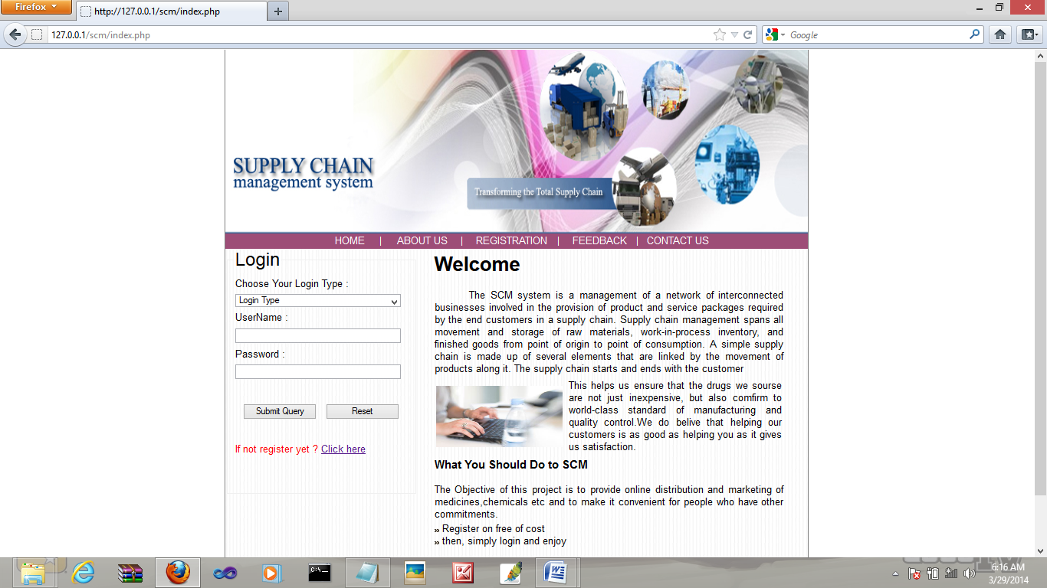

Registration Page :

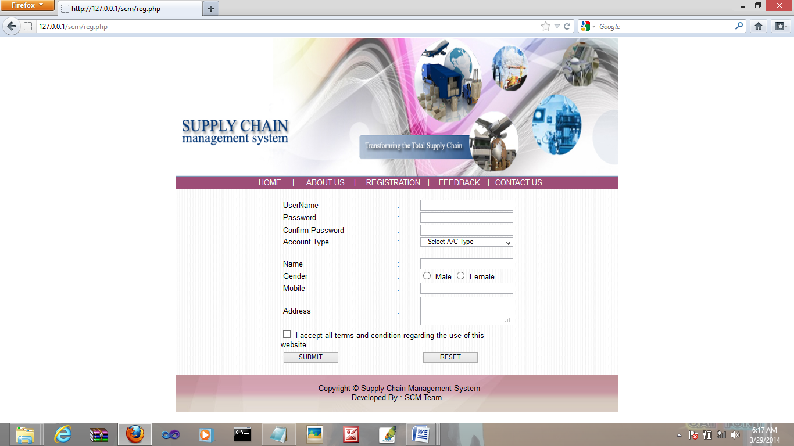

Distributor Home Page :

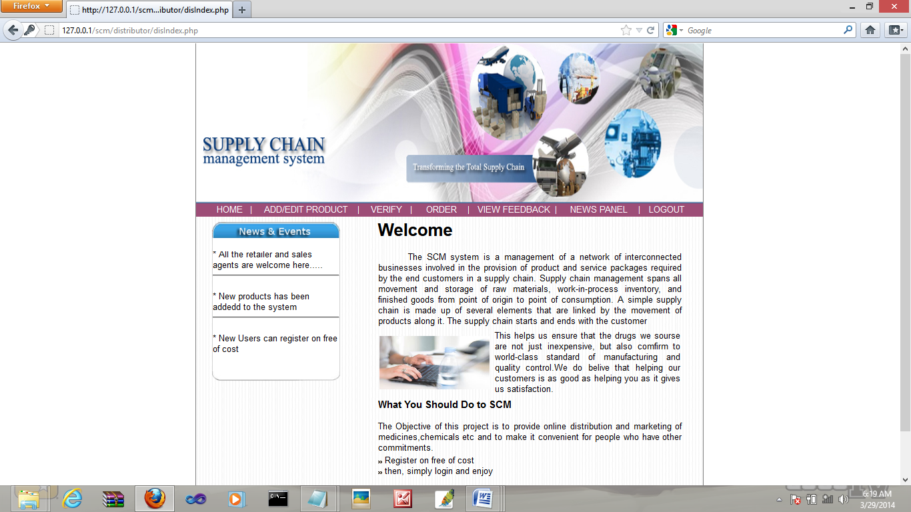

Add/EDIT Product Page :

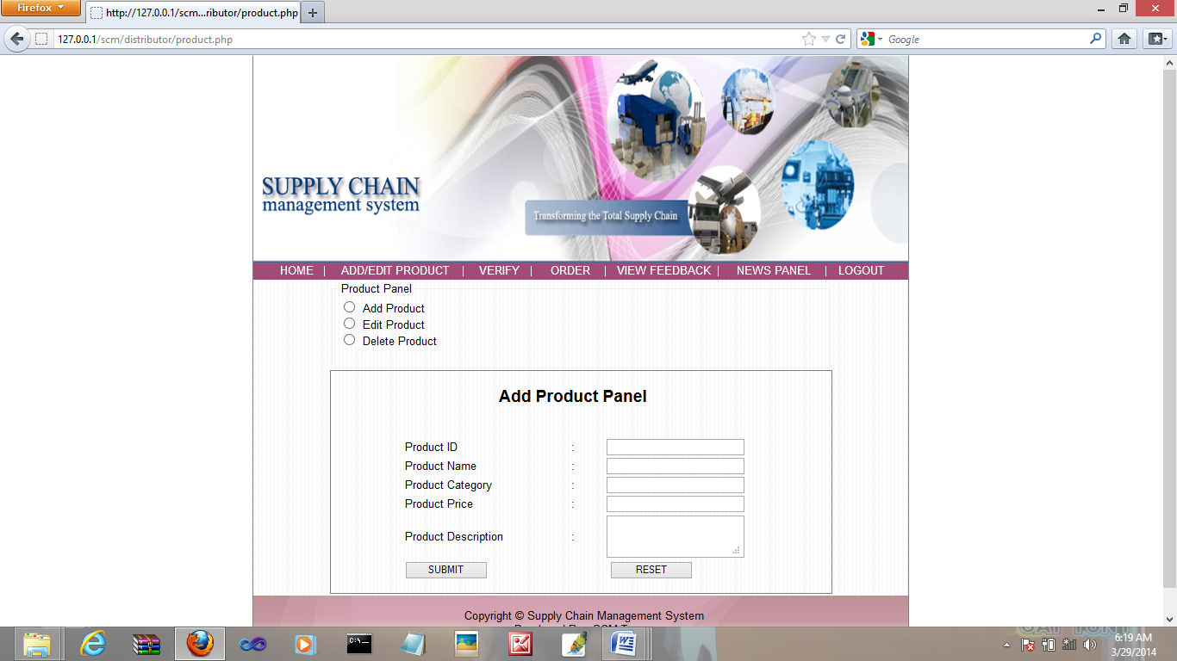

Verify Retailer Page :

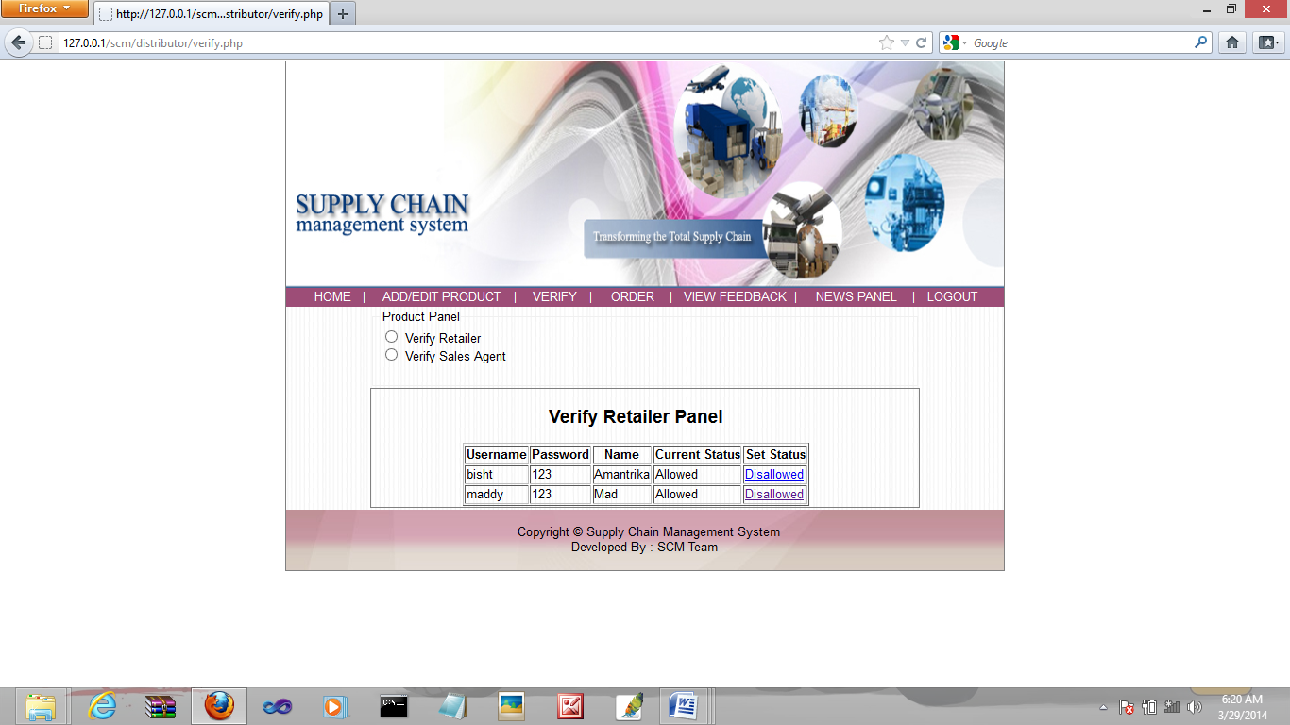

Retailer Home Page :

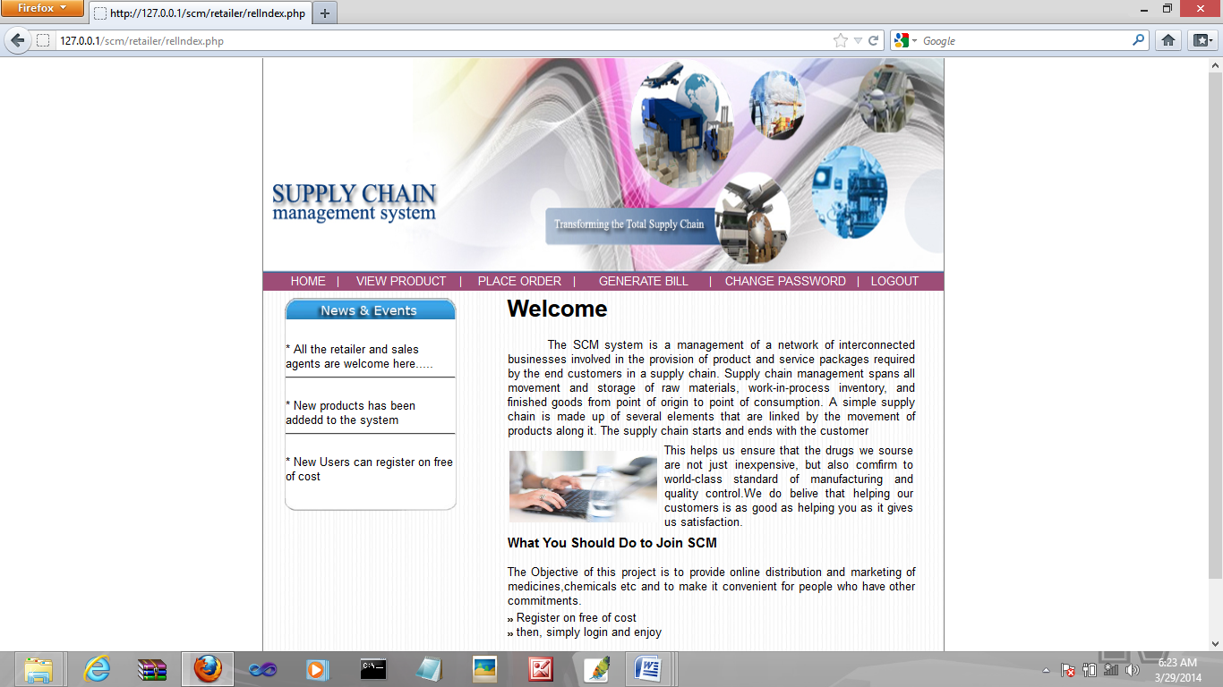

View Product Page :

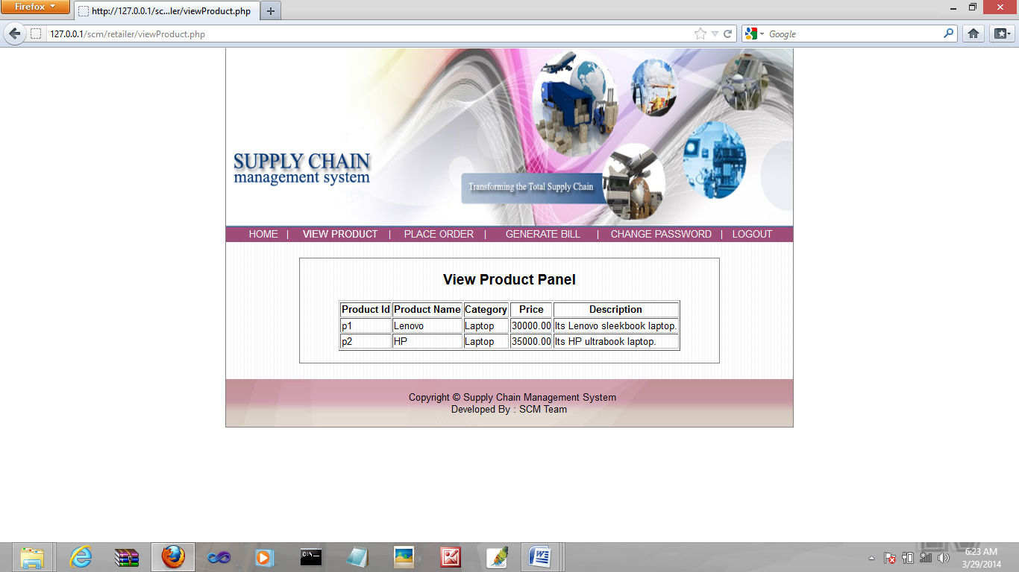

Place Order Page :

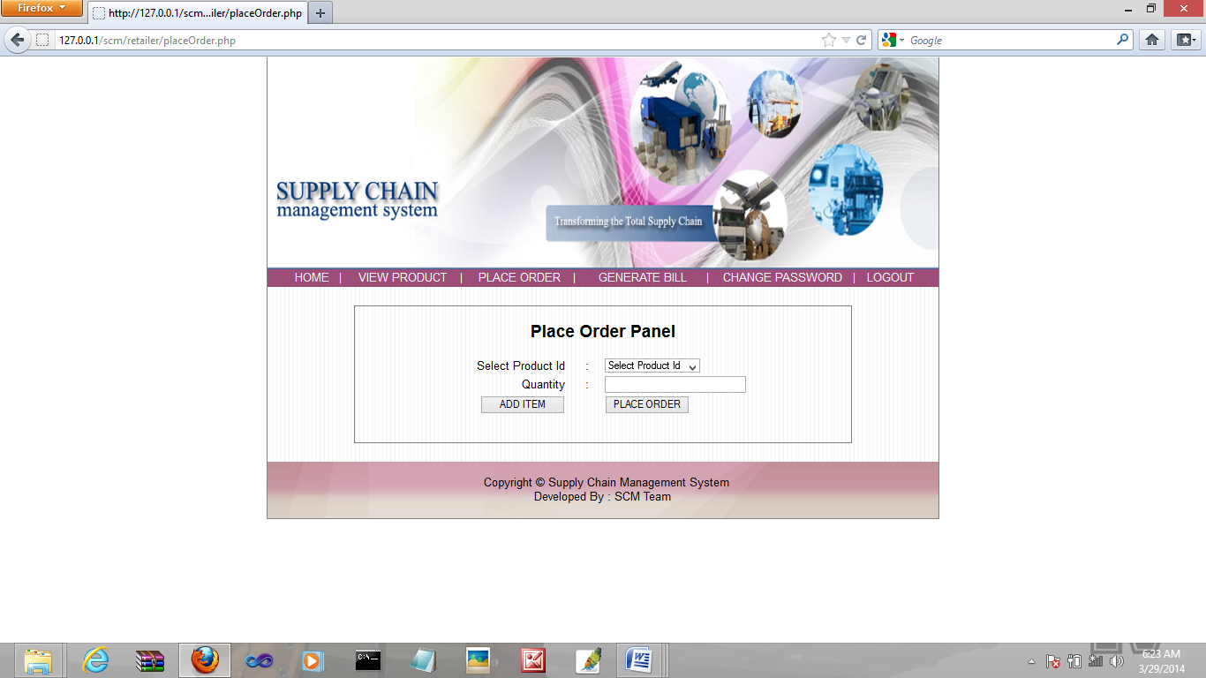

Billing :

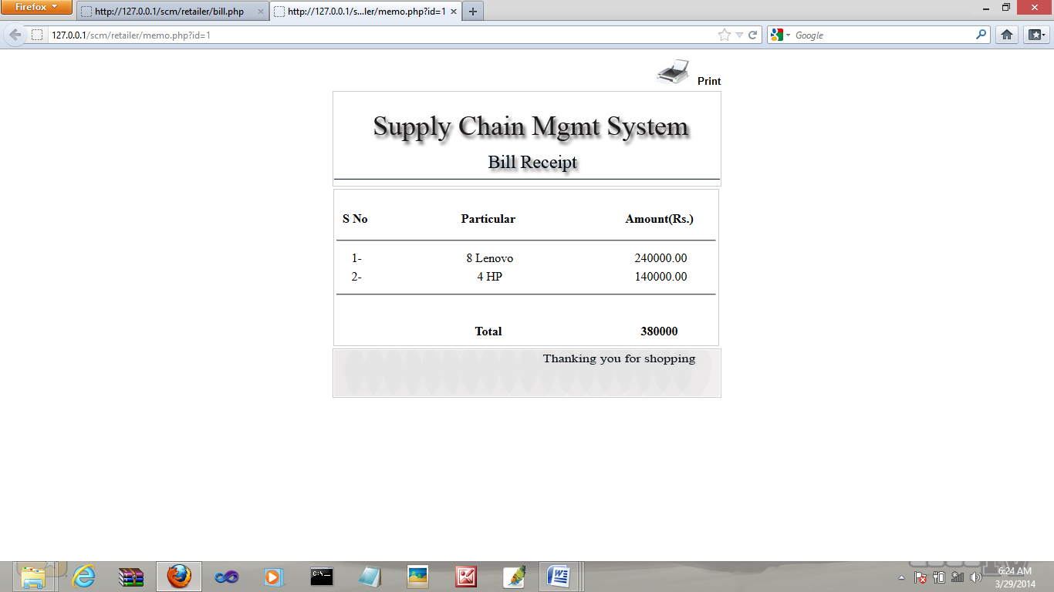

Change Password Page :

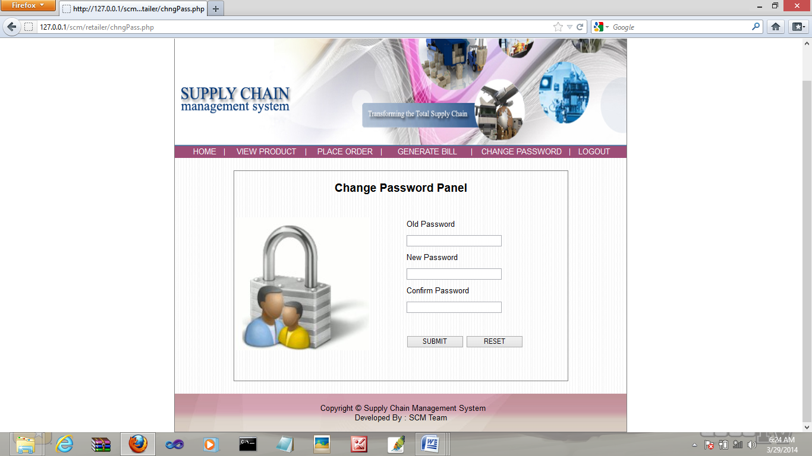

Sales Agent Page :

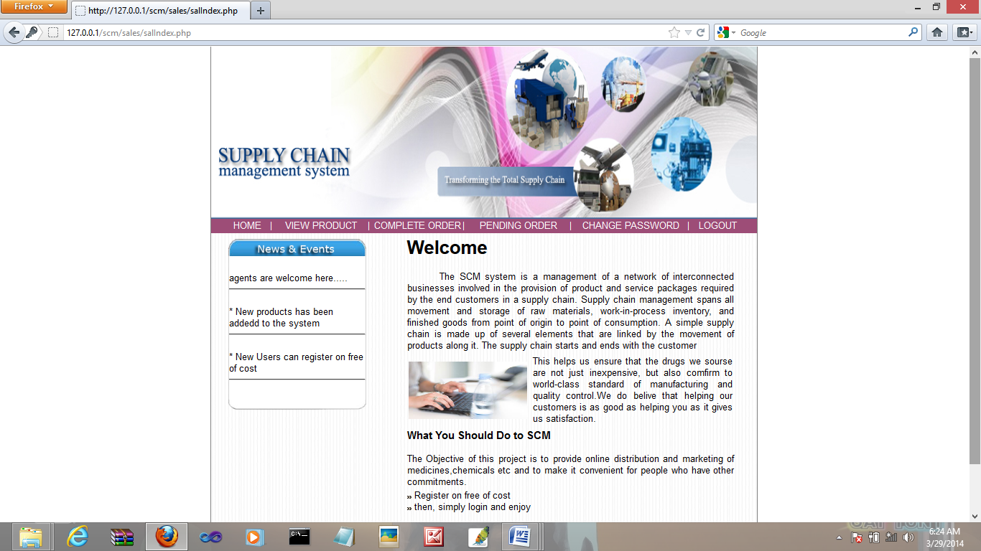

View Complete Order Report Page :

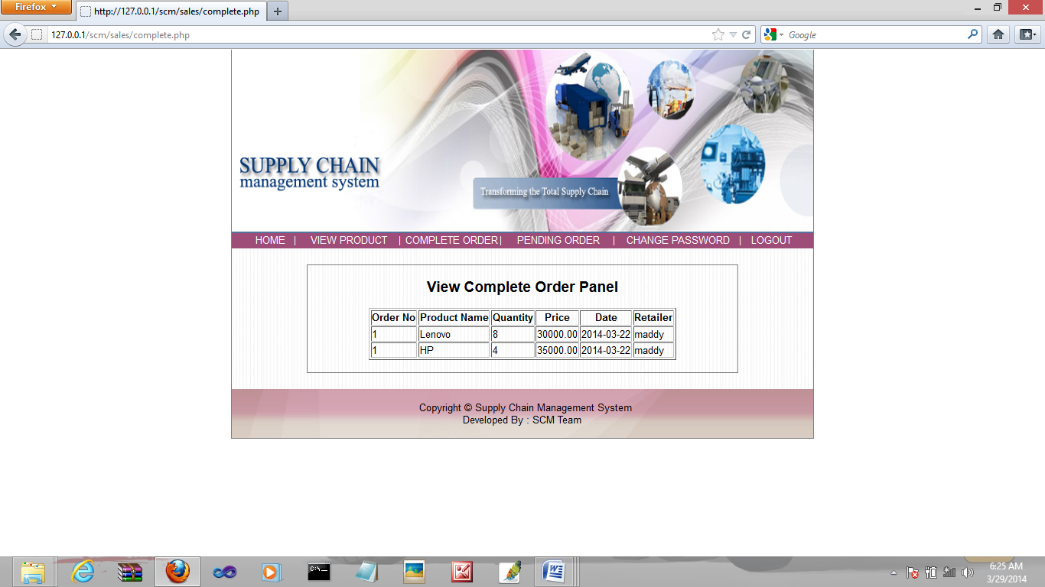

View Pending Order Report Page :

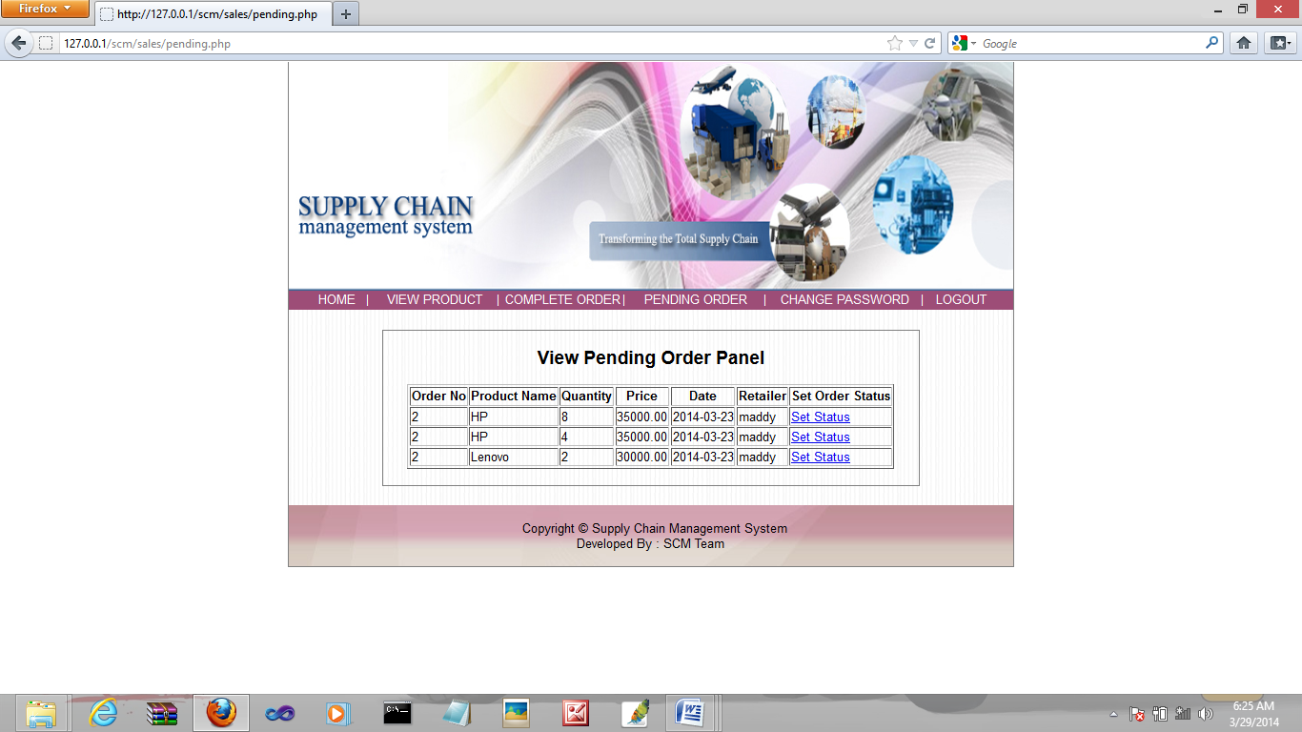

1. **IMPLEMENTATION OF SECURITY**

Security is an important issue for modern IT system. System administrator and security administrator are responsible for safeguard’s organization data and computing infrastructure.

**Password Encryption:** Whatever security measures taken, in any case if anyone with destructive or malicious mind gets access to the database he can temper the critical data. To restrict it we’ve used encrypting algorithm facilitated to us by Microsoft ASP.Net .

Two algorithms’ are there

* SHA1- It takes the password and encrypt it in a string of 40 characters
* MD5- It takes the password and encrypt it in a string of 32characters

The beauty of these Algos are that whatever be the length of password the length of converted string remains same.

However a question arise here that if this thing is that good then why didn’t we used it for storing each and every data????

The answer lies in the fact that not all data are needed to be encrypted as long as we keep the critical data(like password encrypted and safe). It will only increase the load on server and network with no additional advantage. So we’ve not used this encryption Algo on all data blindly.

We have implemented different approach related to security issue for our project “Online Supply Chain Management System”.

**Authorization:**

Super Admin has authorized to give permission to admin for the verification of the retailers and suppliers.

**Information Integrity:**

Only Super admin has right in the modification of the information. There is no possibility by the end user or unauthorized user of hacking the information.

**Detection:**

Super Admin will have a bank up of the project. Also there is a complex and alphanumeric password for admin and student. Super admin itself has a complex and alphanumeric password. There is a option for changing the password by all the admin and itself after every month.

**10. FUTURE SCOPE AND ENHANCEMENT OF THE PROJECT**

* In the future, this project can be enhanced by increasing the chain i.e. starting from the

Company.

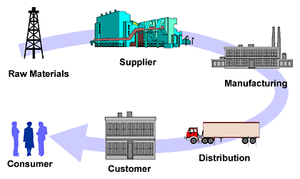

* It can then include the supplier and manufacturer module which can supply raw material and produce the finished product respectively.
* Adding the payment gateway in the project. Adding the payment gateway in the project.
* Online stores are usually available 24 hours a day, and many consumers have Internet access both at work and at home.
* The Supply Chain Management System is developed using PHP and MySql which fully meets the objectives of the system for which it has been developed.
* This can be used in corporate world.
* The system is operated at a high level of efficiency and all the users associated with the system understand its advantage.
* The system solves the problem and it was intended to solve as requirement specification.
* Can be used anywhere, anytime within a WAN as it is a web based application.
* Other establishments such as internet cafes and schools provide access as well. A visit to a conventional retail store requires travel and must take place during business hours.

**11. Conclusion**

The objective of this project was to build a program for maintaining the details of all Supply Order .The system developed is able to meet all the basic requirements. It will provide the facility to the user so that they can keep tracks of all the equipments being supplied. The management of the Inventory will be also benefited by the proposed system, as it will automate the whole supply procedure, which will reduce the workload. The security of the system is also one of the prime concerns.   
There is always a room for improvement in any software, however efficient the system may be. The important thing is that the system should be flexible enough for future modifications. The system has been factored into different modules to make system adapt to the further changes. Every effort has been made to cover all user requirements and make it user friendly.

**Goal achieved:** The System is able provide the interface to the user so that he can replicate his desired data.

**User friendliness:** Though the most part of the system is supposed to act in the background, efforts have been made to make the foreground interaction with user as smooth as possible. Also the integration of the system with Inventory Management project has been kept in mind throughout the development phase.

**12. Bibliography**

Designing and implementation phase: -

1. Software engineering: a practitioners approach by roger s pressman.
2. System analysis and design by Elias m. Ewad.
3. DBMS : Bipin C Desai

**Coding phase: -**

1. PHP (BIBLE)
2. PHP (BLACK Book)
3. PHP (Complete Reference)

Referenced Sites:

[www.w3school. com](http://www.w3school.microsoft.com)

[www.php.net](http://www.php.net)